DTS207TC - Database Development and Design Lab 8: Data Analytics and AI platform

Xi’an Jiaotong-Liverpool University, Suzhou, China

2025

**Content:**

1 Installation: Download from the RapidMiner website 2

2 General 2

2.1 Getting started with Altair AI Studio 2

2.2 RapidMiner Studio - GUI Intro 3

3 Data access and preparation 5

3.1 Data Loading via a Process 5

3.2 Data Preparation 12

3.3 Connecting to Databases 21

4 Machine Learning 27

4.1 Creating a 'Decision Tree' Model 27

4.2 Applying the Model 29

4.3 Testing a Model 30

4.4 Validating a Model 32

### Installation: Download from the RapidMiner website

To download Altair AI Studio from the RapidMiner website:

1. Go to the [RapidMiner website](https://my.rapidminer.com/nexus/account/index.html).  
   <https://my.rapidminer.com/nexus/account/index.html>
2. Sign in if you haven't already. See below if [you need to create an account](https://docs.rapidminer.com/latest/studio/installation/index.html#create-account-1) through your educational email.

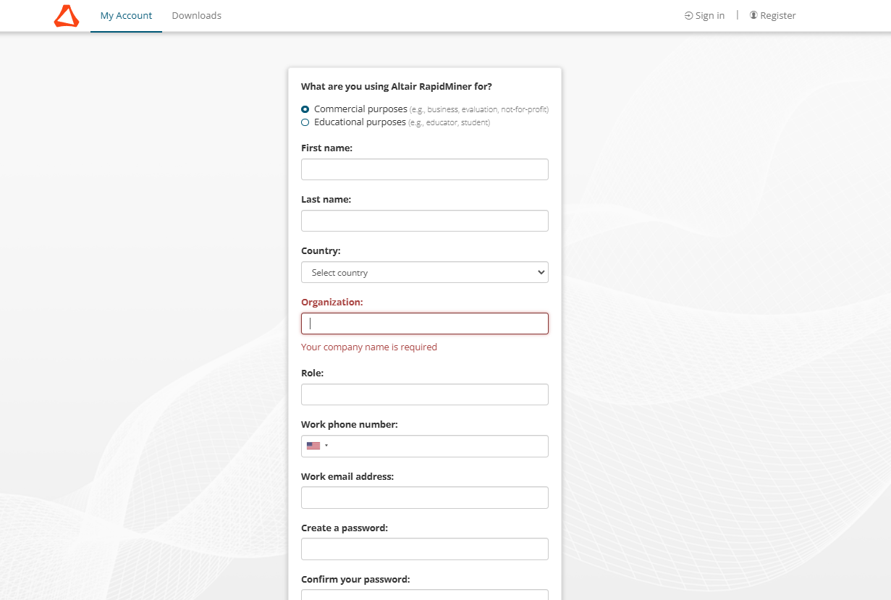

Download the APP

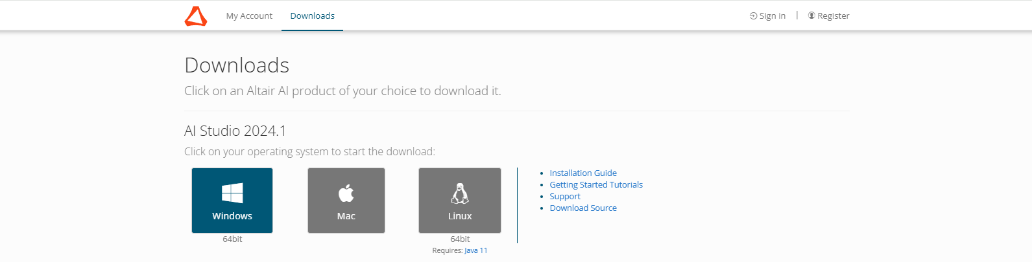

s

### General

#### Getting started with Altair AI Studio

Selecting File > New Process, and choosing the Learn tab.

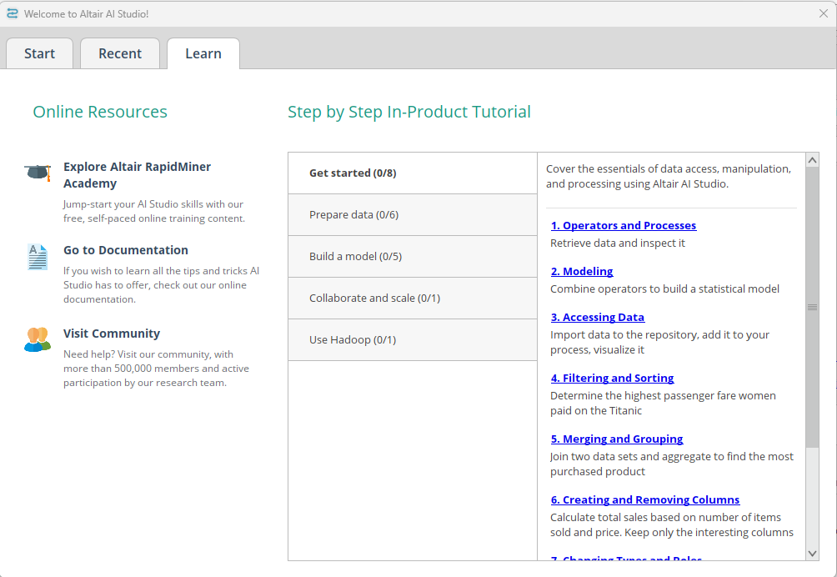

#### RapidMiner Studio - GUI Intro

*Video address:* [*https://academy.rapidminer.com/learn/video/rapidminer-studio-gui-intro*](https://academy.rapidminer.com/learn/video/rapidminer-studio-gui-intro)

Find your way around RapidMiner Studio's graphical user interface. This part will help you to familiarize yourself quickly with all elements of the design and the Results view.

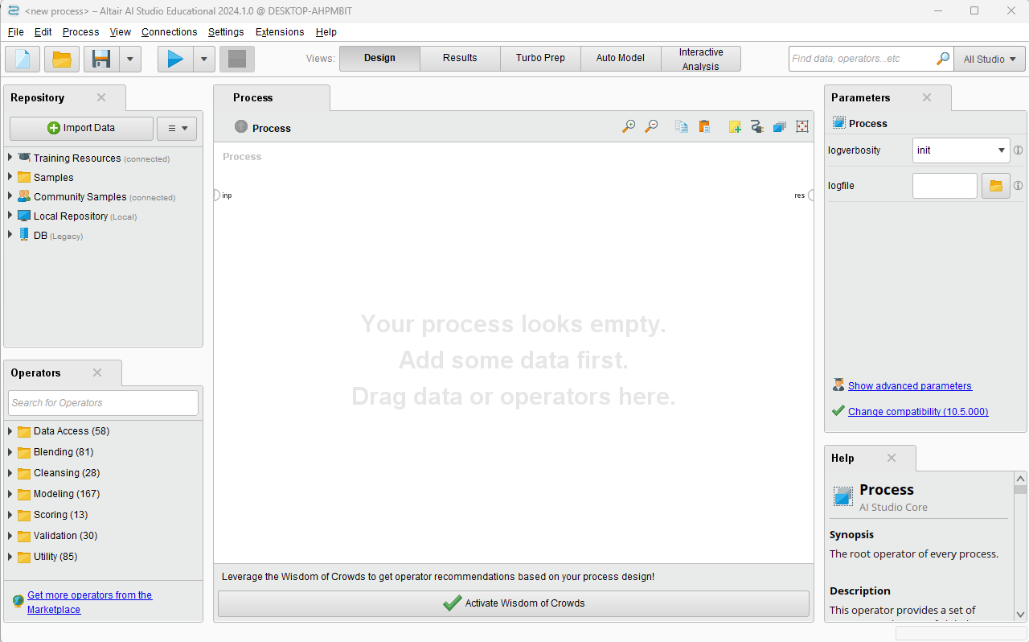

Operators> Data Access> Select the retrieve operator and drag and drop into the process panel.

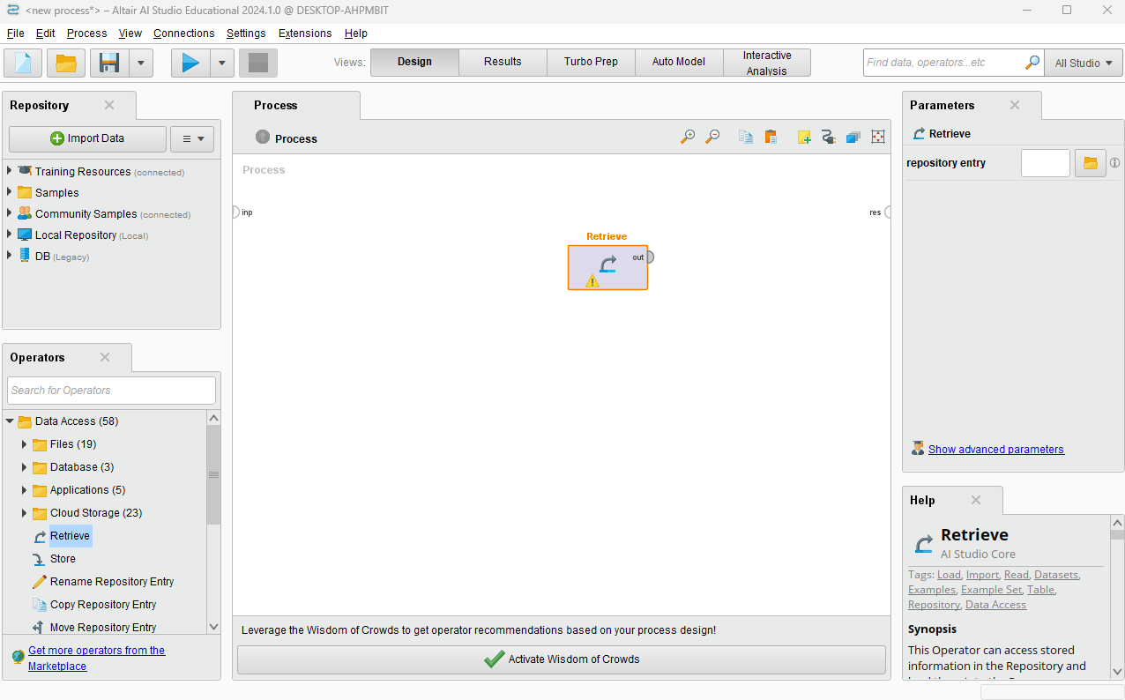

Select the titanic dataset which is preloaded in RapidMiner Studio.

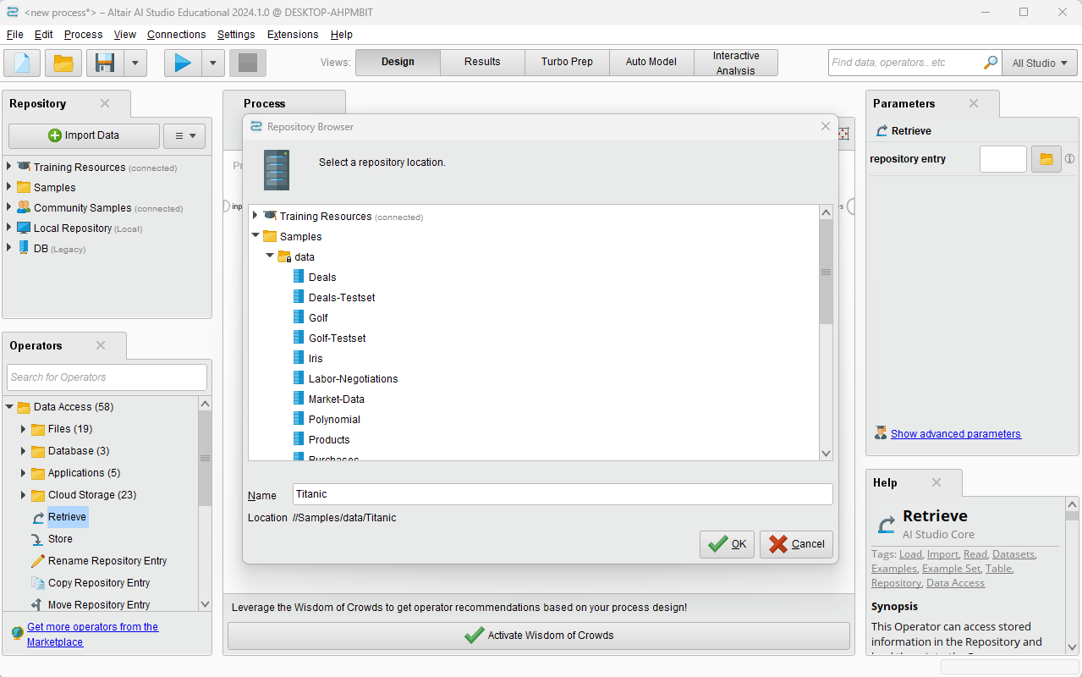

Connect retrieve to a resolves port. And then click run button.

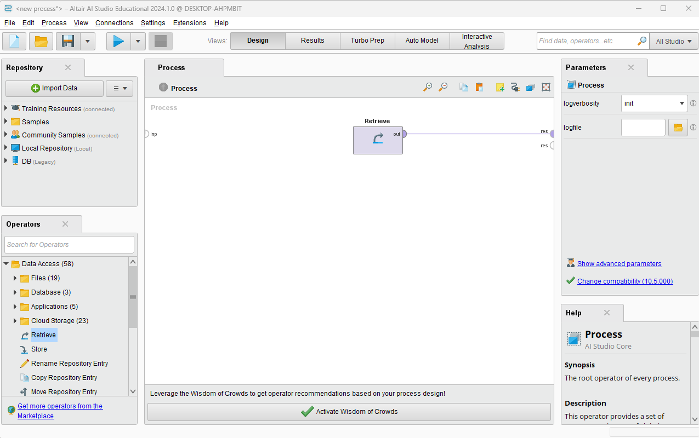

The results view displayed.

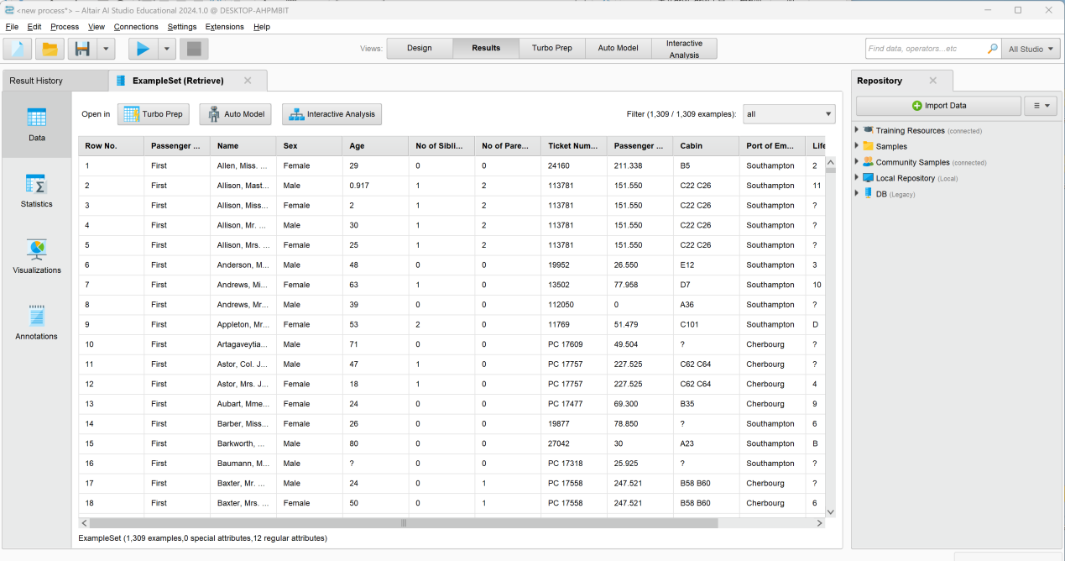

### Data access and preparation

#### Data Loading via a Process

*Video address:* [*https://academy.rapidminer.com/learn/video/data-loading-via-a-process*](https://academy.rapidminer.com/learn/video/data-loading-via-a-process)

When creating a first model for your study or when you are doing rapid prototyping the data will often come from a flat file of some sort. This part will show you how to load an excel spreadsheet.

Find and drop the operator. Click Import Configuration Wizard… and find the document.

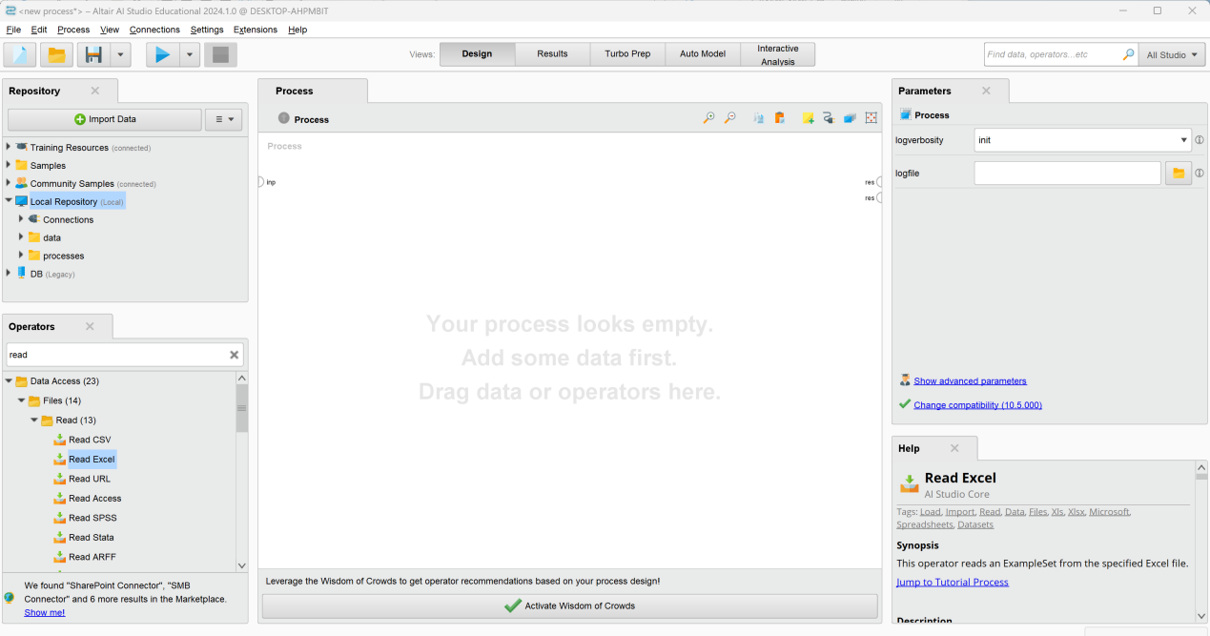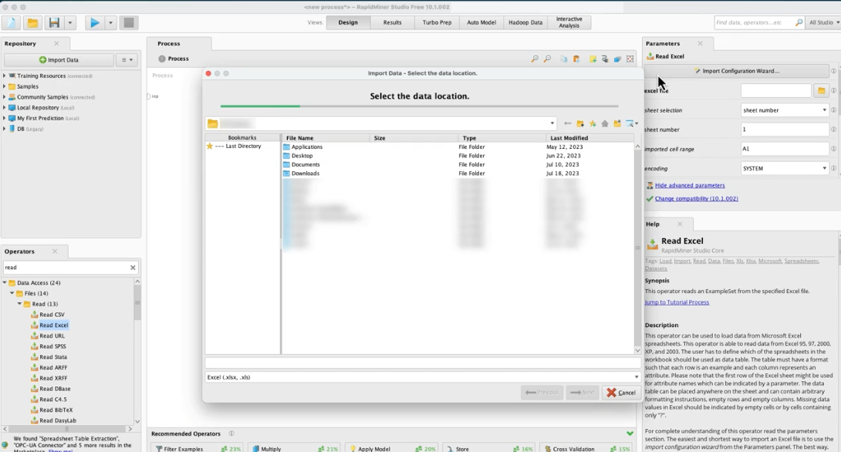

You can set the cell range to start just at the first relevant row. If you have a header row, you can adjust it here. So that the attributes or columns get named accordingly. And then click Next.

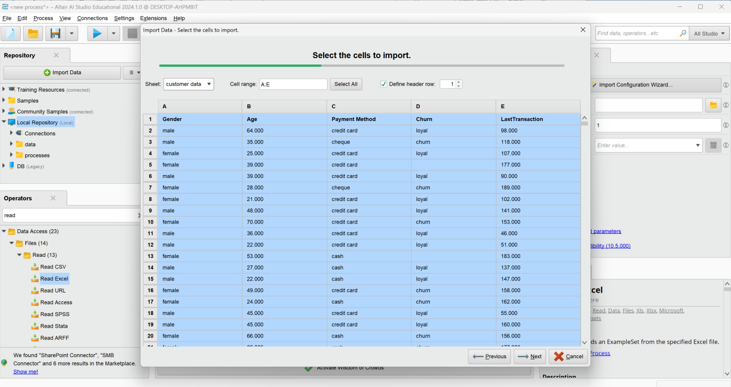

In the final step of the input configuration visit, we can now omit columns from being loaded by excluding them. We can change the names, or we could change data type and role. And then we can click finish.

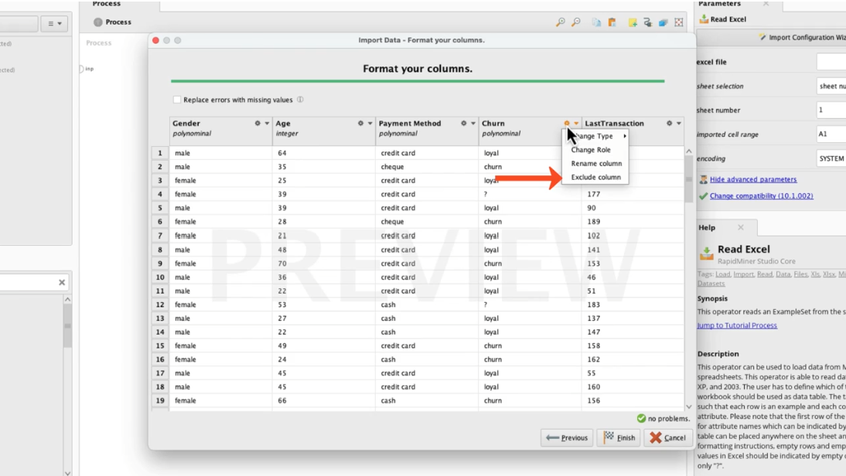

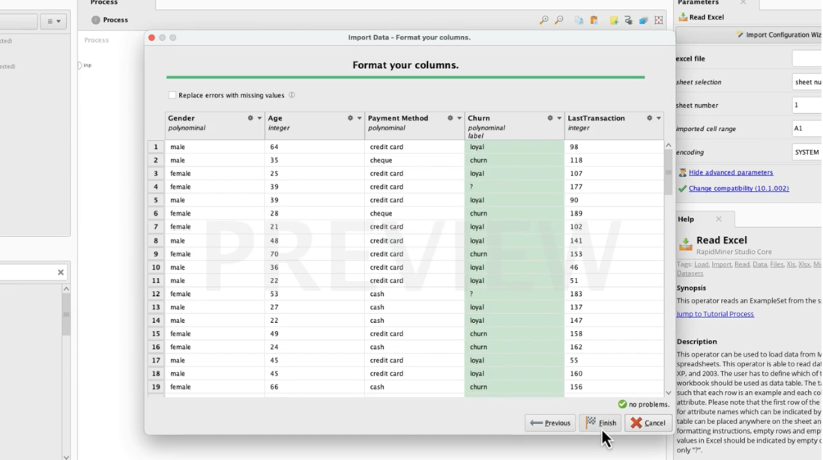

Connect the ports and run it. The result as shown.

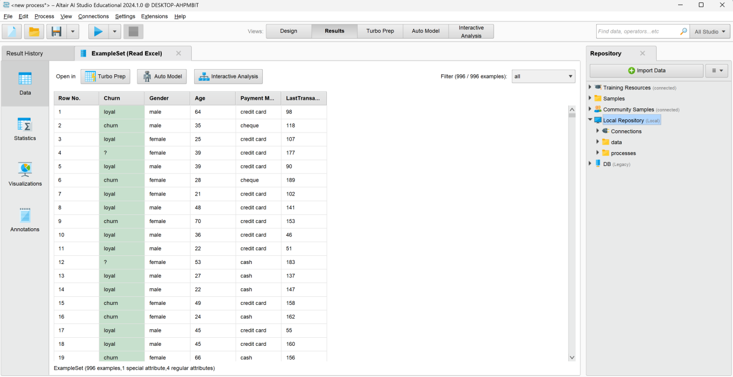

You can add a copy into your repository by storing what we just loaded. First, we should save the work we have done so far by saving the process. The formal way is to open the file and select Save Process. And then select the destination folder and then give it a name.

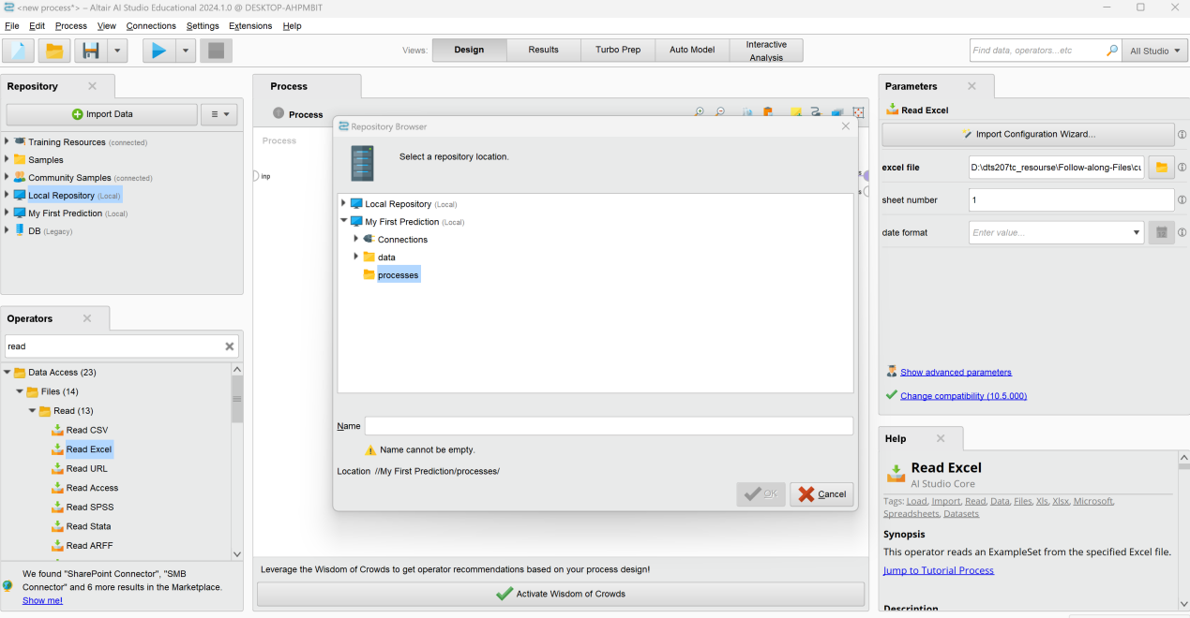

Or if we go to a repository panel, we can right click on the folder where you want to store process. Select store process here. And give it a name.

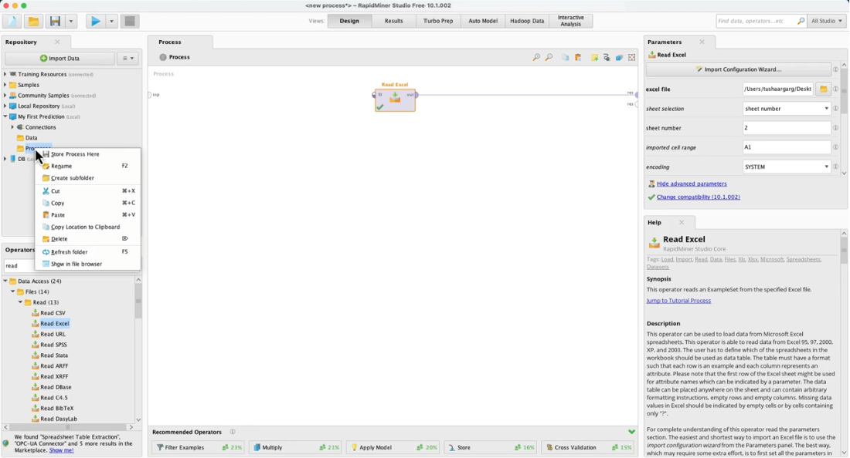

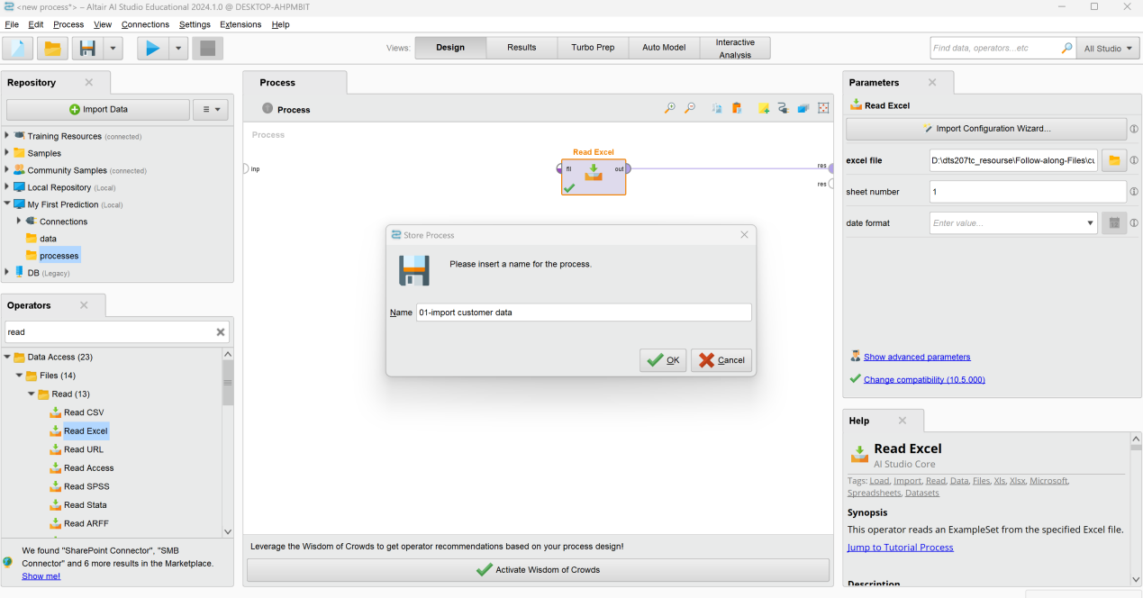

Use global search to find the operator. Drag it over and drop it on the line automatically connect the ports.

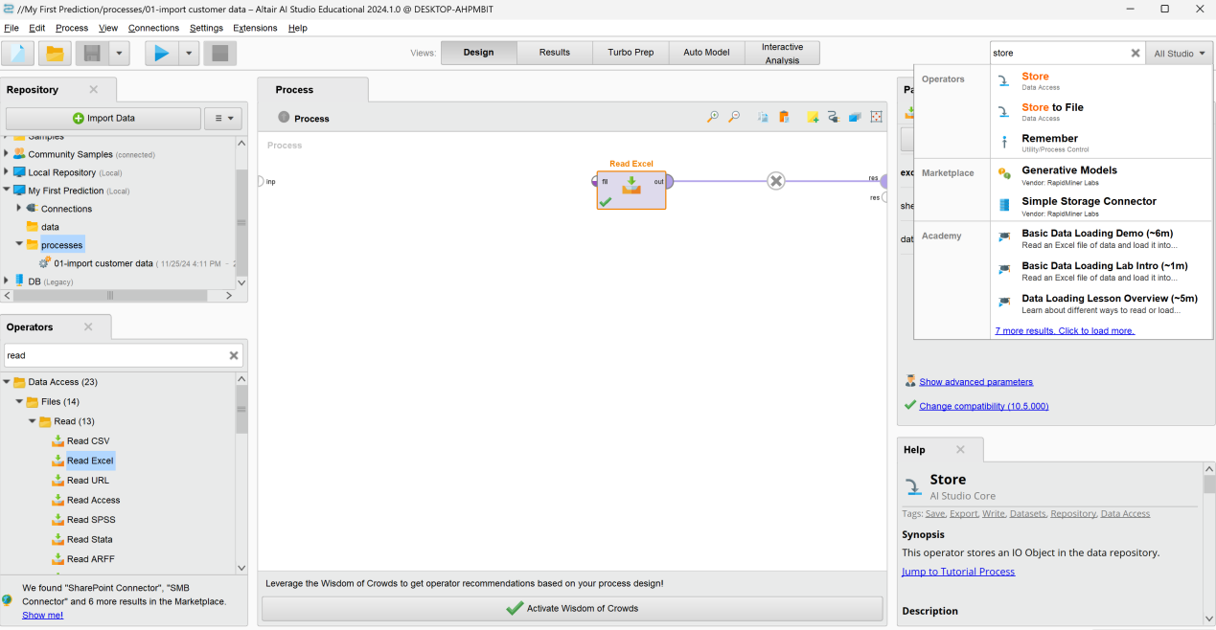

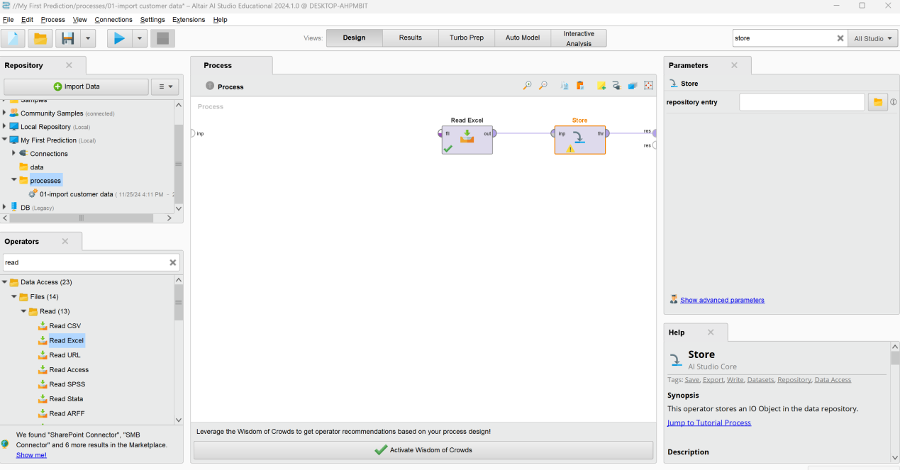

The next step is, to define our parameters for the operator. We will overwrite our existing data file or if you haven’t followed along in the data import module, simply create a new one called Customer+Data. And then click the run button.

Export and import the process we just created.

First, highlight the process we want to export by selecting it in our process folder. Then, go to the file menu and select export process. Then, select the place in the folder or create one.

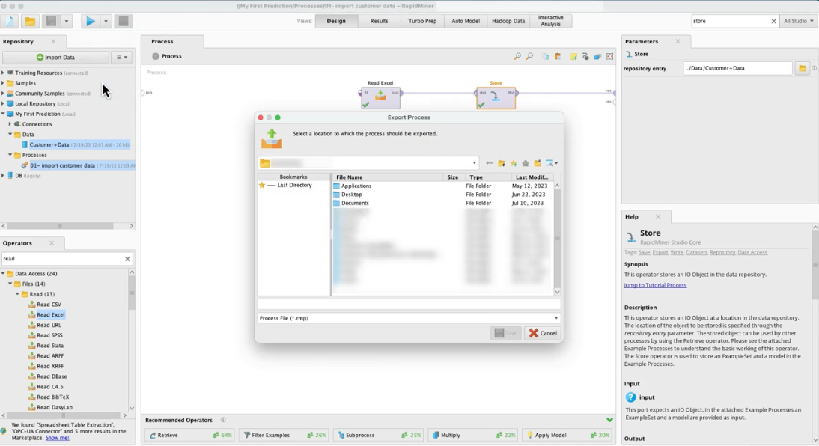

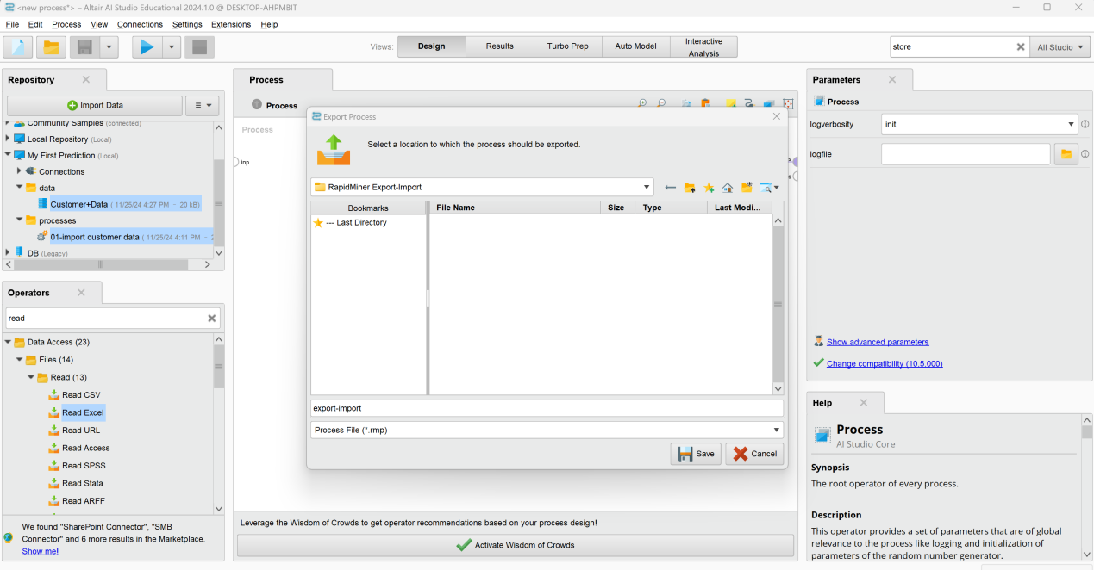

Before we proceed to the import, let’s clean our process panel by creating a blank process. Select the button which looks like a blank sheet in the menu bar.

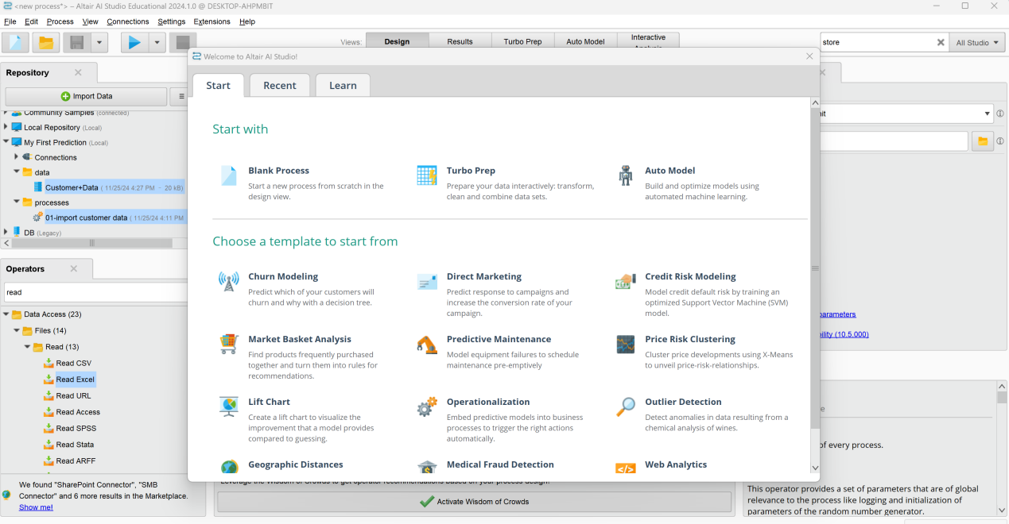

Select import process from the file menu, navigate to the folder, select your process with the ending RMP. And then store the process here. We now have two versions of the same process. So we can do some housekeeping and learn this way how to delete processes or entire folders. Just do a right click on the item and select delete.

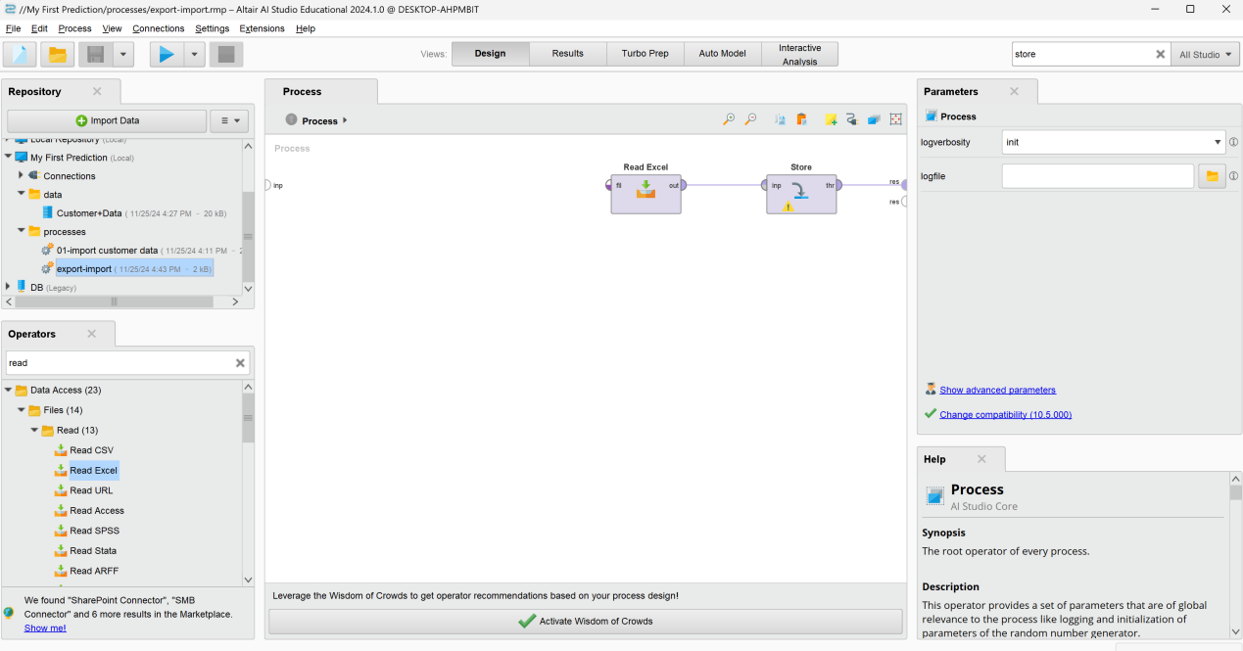

#### Data Preparation

*Video address:* [*https://academy.rapidminer.com/learn/video/data-preparation*](https://academy.rapidminer.com/learn/video/data-preparation)

Here we will show you some of the great operators available in RapidMiner to help you with this first step of the predictive analytics lifecycle.

The file we are using is called raw customer churn data. As mentioned before, drag and drop the read excel operator into our process panel. And then we select the data file via the available option in the parameters panel.

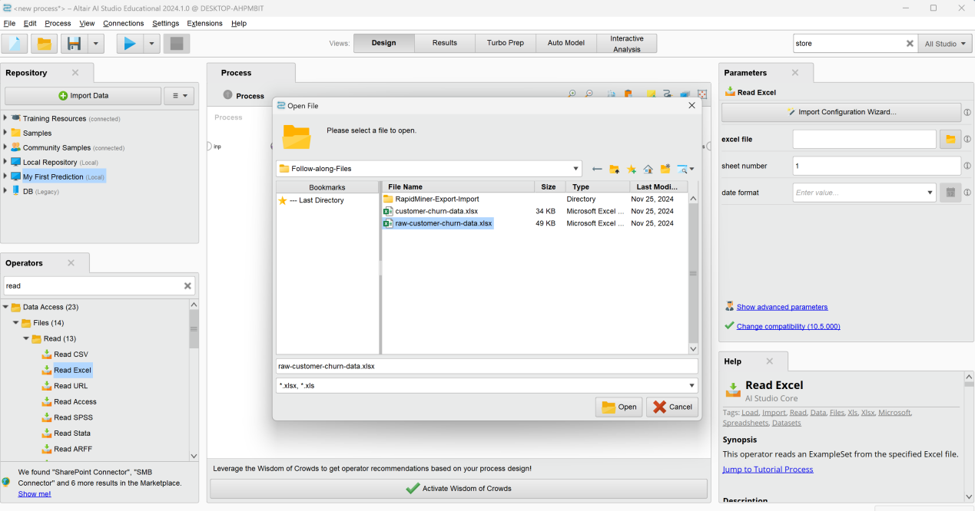

To get a first look at the data, we connect the output port of the operator to our results board, and run the process via the shortcut key F11, or run button. You can probably spot some of the issues that our example set has immediately, as we have purposefully placed them in the first few lines.

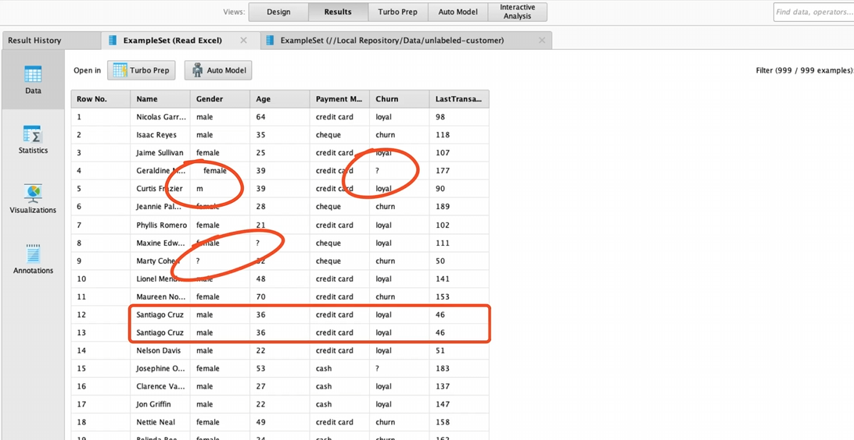

In the column missing, you can see that we have some blanks in the gender and age attributes. And as we click on gender, we see that there are 4 unique values, where we should have only 2. Further, we have some missing values in our churn attribute, and the name Santiago Cruz appears twice so that might be a duplicate entry, which we may need to remove.

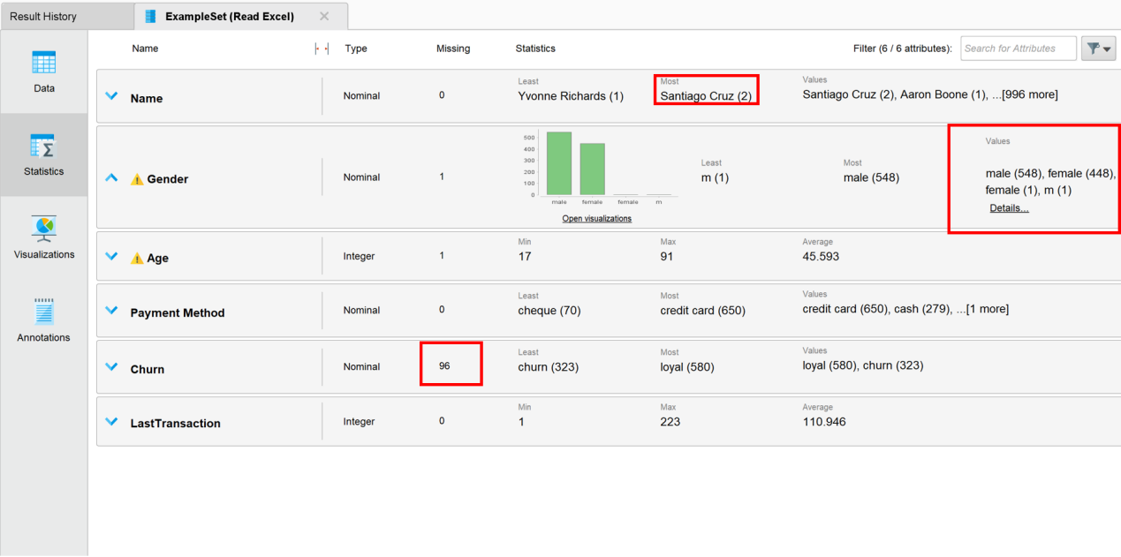

To make a decision on how to address each of our data issues, we need to consider our overall analytics task first. We want to use the information at hand. To find customers who are likely to churn, so we can encourage them to stay as a customer. For that, we can use the historical information of those, where we know if they are loyal or churners. With that input, we can build a model to make a prediction on the others where we don’t know yet how they’re likely to behave. So the ones with the information on their loyalty are to be placed in one subset to be used as input for creating a model. And we want the ones without churn information to be grouped in another subset, so we can predict how they will act.

Steps:

-split example-set in labeled and unlabeled subset-sets

-prepare training-data

-remove leading and trailing blanks

-deal with incomplete examples

-replace false entries

-remove duplicates

Firstly, drag and drop the trim operator into the process panel to remove the whitespace.

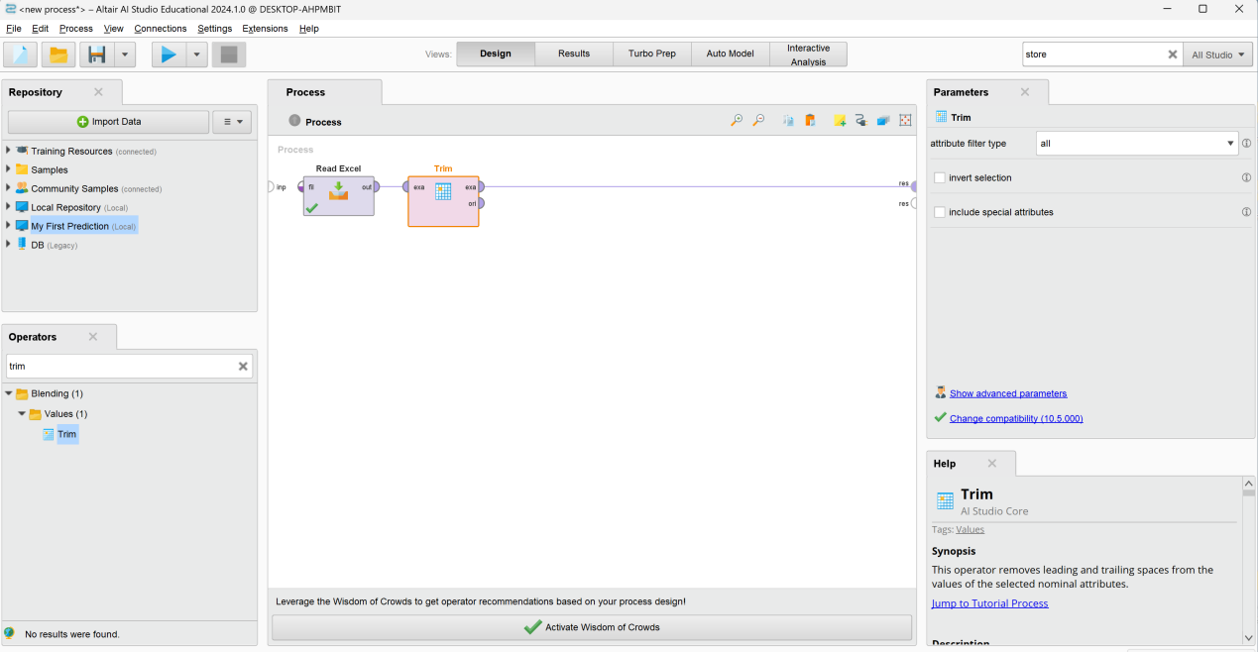

Next, handle the examples with missing age or gender values. Find the Filter Examples and drop it.

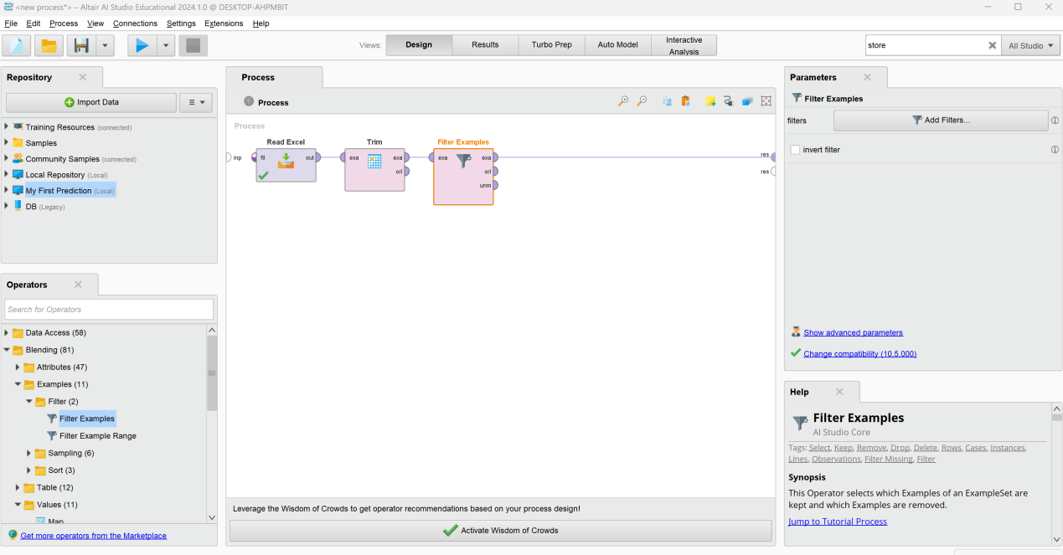

Select the read operator and leave all the defaults and then we click finish.

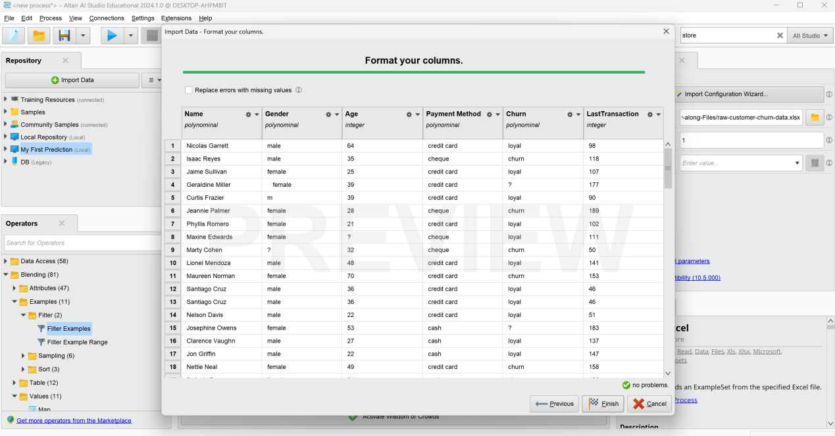

Select filter examples. To configure it correctly, we want to select the add filters button in the parameters panel. Add the filters for gender and age and set them both to is not missing. And then click OK button.

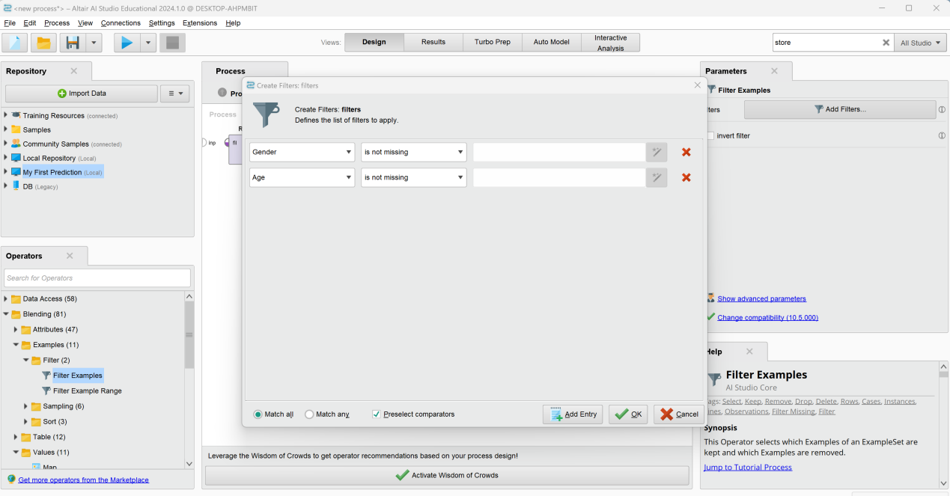

The next item on our data preparation list is the removal of a duplicate entry. So we will drag and drop the remove duplicate operator onto our connection. And we will leave it set to all as the attribute filter type. This means that two examples are only considered duplicates if they’re identical with respect to all attribute values. To fix the issue with the gender value, which was an m instead of male. We will use replace operator.

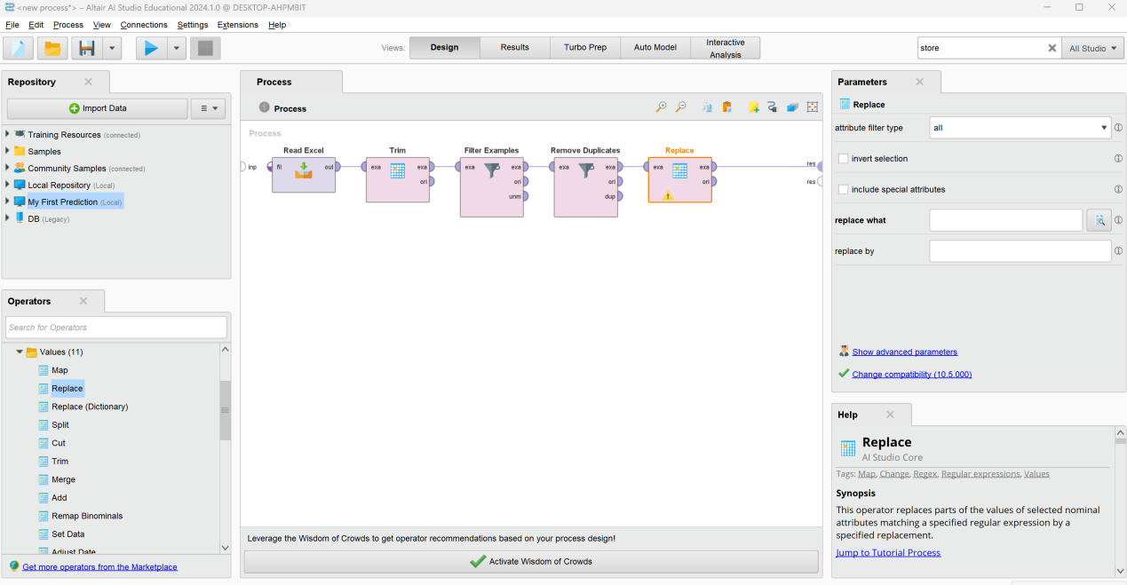

In the parameters panel, we set up that we want to work on a single attribute, which is gender, and we want to replace m by male. Here, we need use regular expression, which is a special text string for describing a search pattern. And then click Apply button.

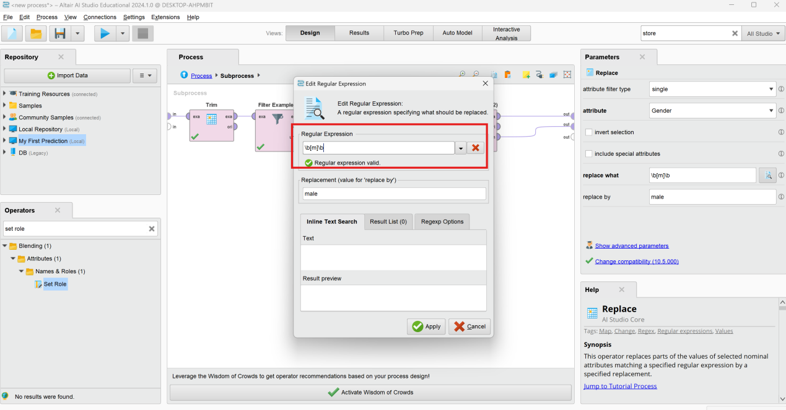

Copy and paste the Filter Examples. Then adjust the setting to filter out examples where churn is not missing.

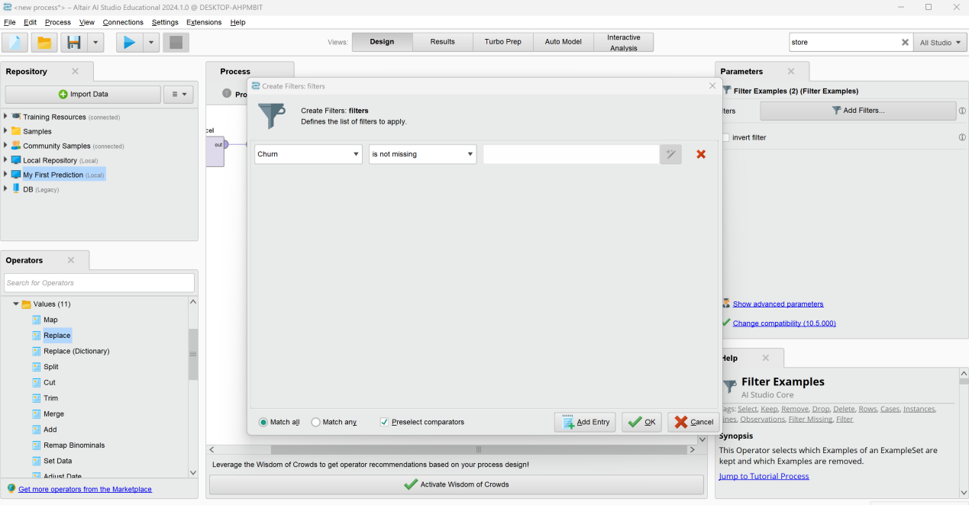

Use the unmatched port and store these examples using the store operator. Save the dataset in the data folder and call it unlabeled customers.

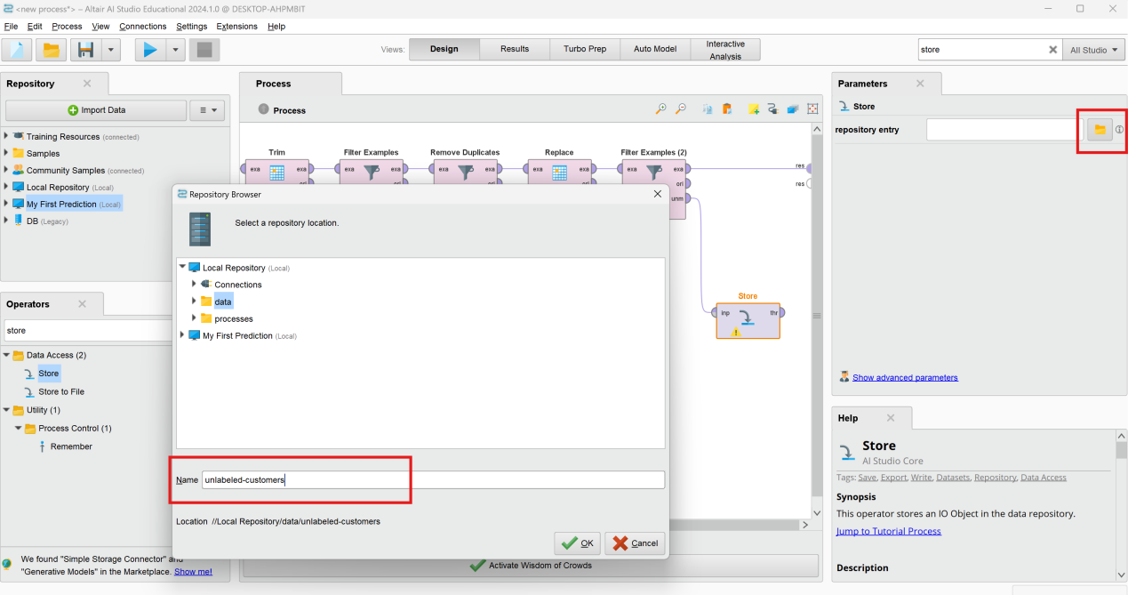

To get rid of the attribute to save space, we will use the select attributes operator and we’ll set it to exclude attributes> one attribute>Churn.

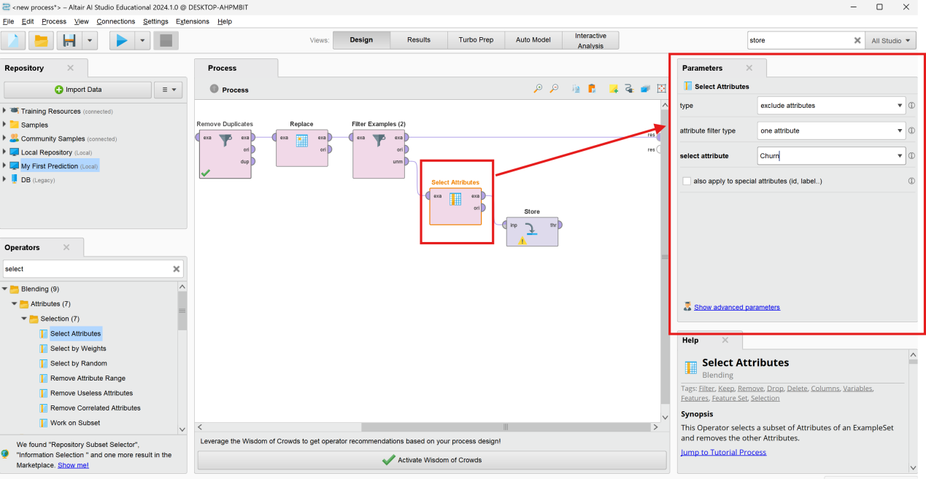

And we now storing our unlabeled data for later. Now, we can arrange things nicely and finally prepare our remaining example set to become our training data. For that, we will remove unnecessary information first, which is in our case the names. Again, the select attributes operator with the type exclude will do the trick.

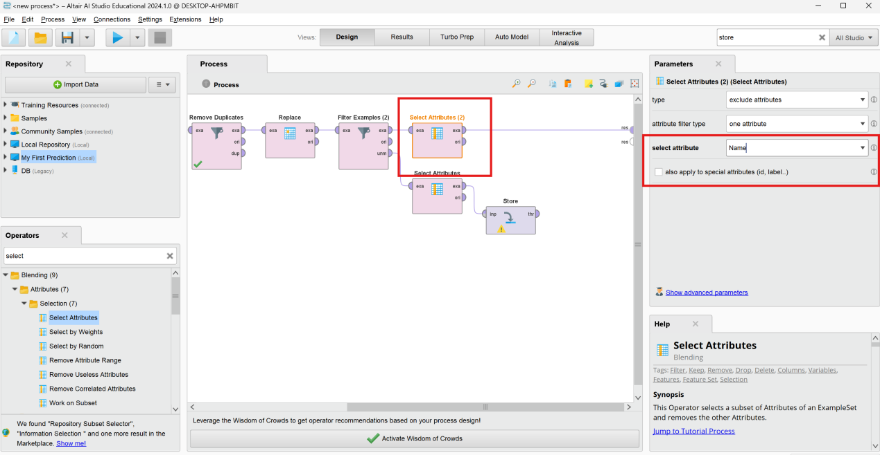

To move all the operators which we used for data cleaning into a subprocess. Just mark all the operators, and then we use the right mouse button to send them all into a new subprocess, which you could also give a descriptive name if you want.

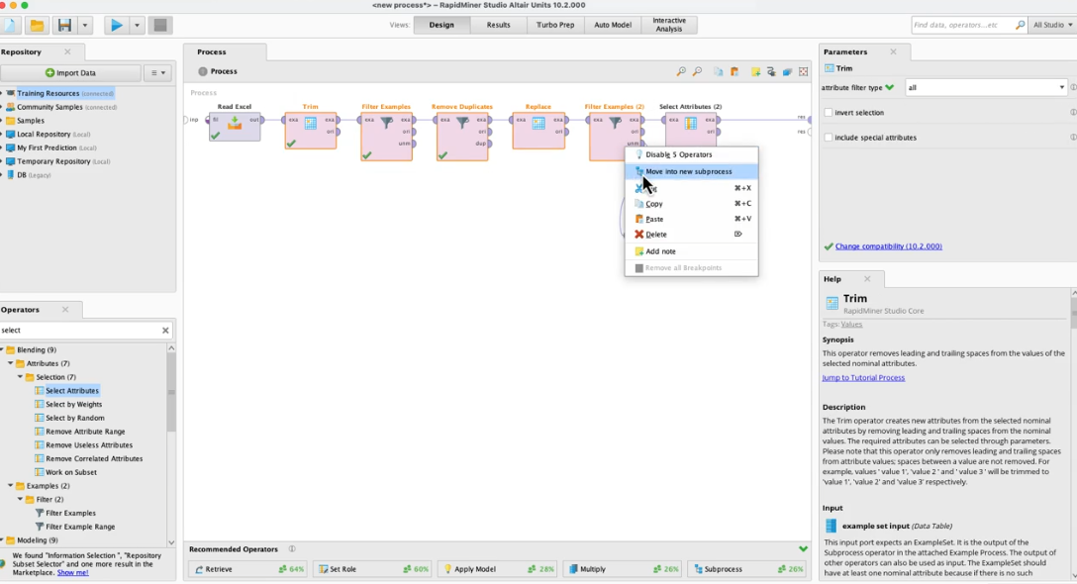

In order for the model to know what is the target variable, we need to use the setRole operator.

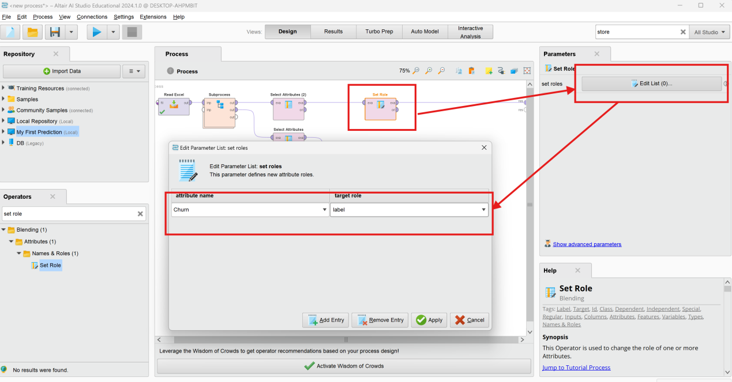

To attribute will now be automatically disregarded for building the model, but will be used for validation. Finally, connect the store operator to the results and select the run process button.

The results shown as:

There are two fully prepared subsets in the results view with the label identified in the green.

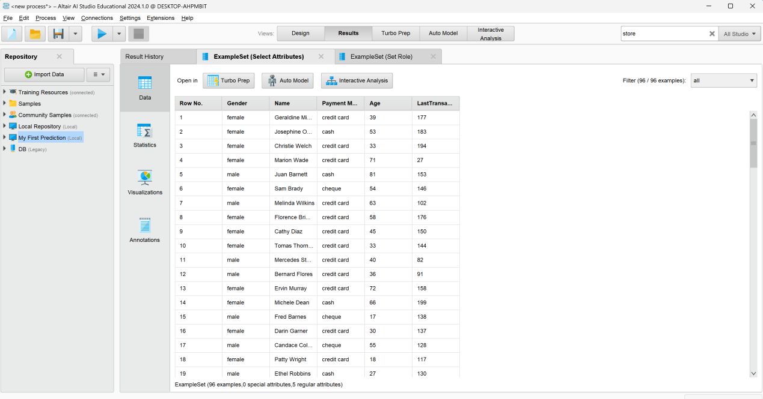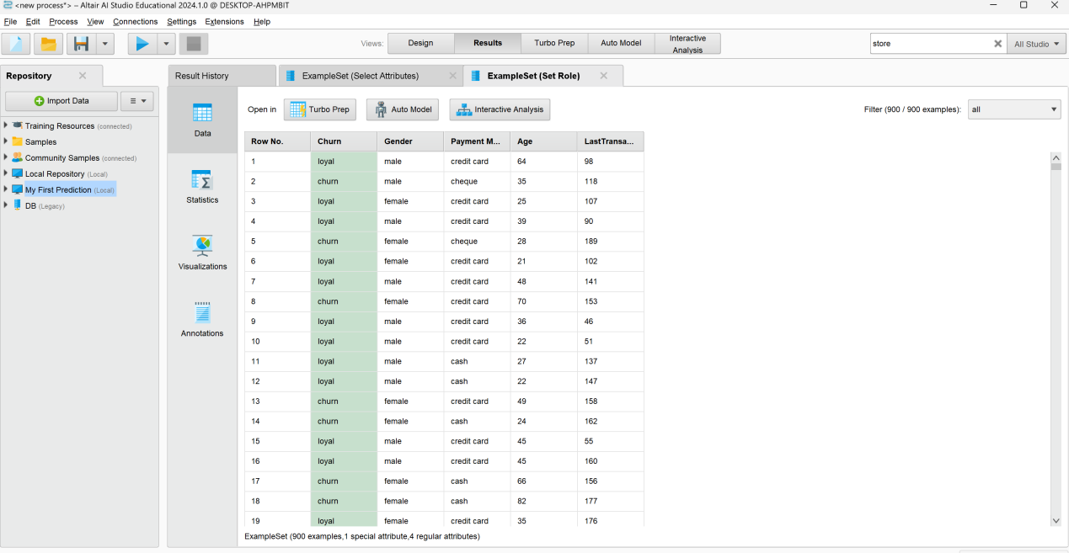

#### Connecting to Databases

*Video address:* [*https://academy.rapidminer.com/learn/video/connecting-to-databases*](https://academy.rapidminer.com/learn/video/connecting-to-databases)

In this part, we will show you how you can create connection templates for yourself or to be used by others. We will demo the configuration for relational databases using a Postgres database.

To create our first connection, we will go to the connection menu and select create connection.

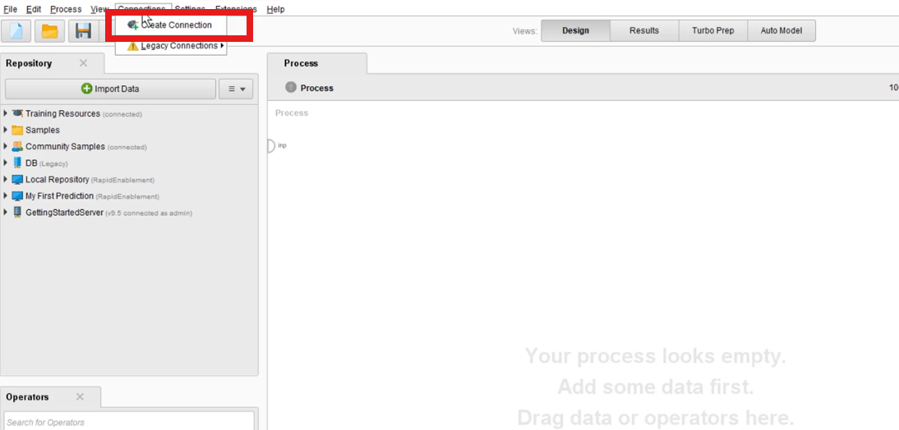

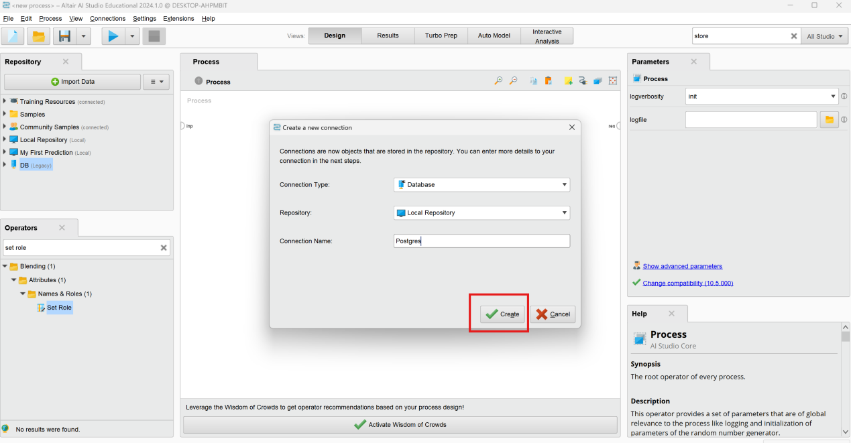

Add note and click setup.

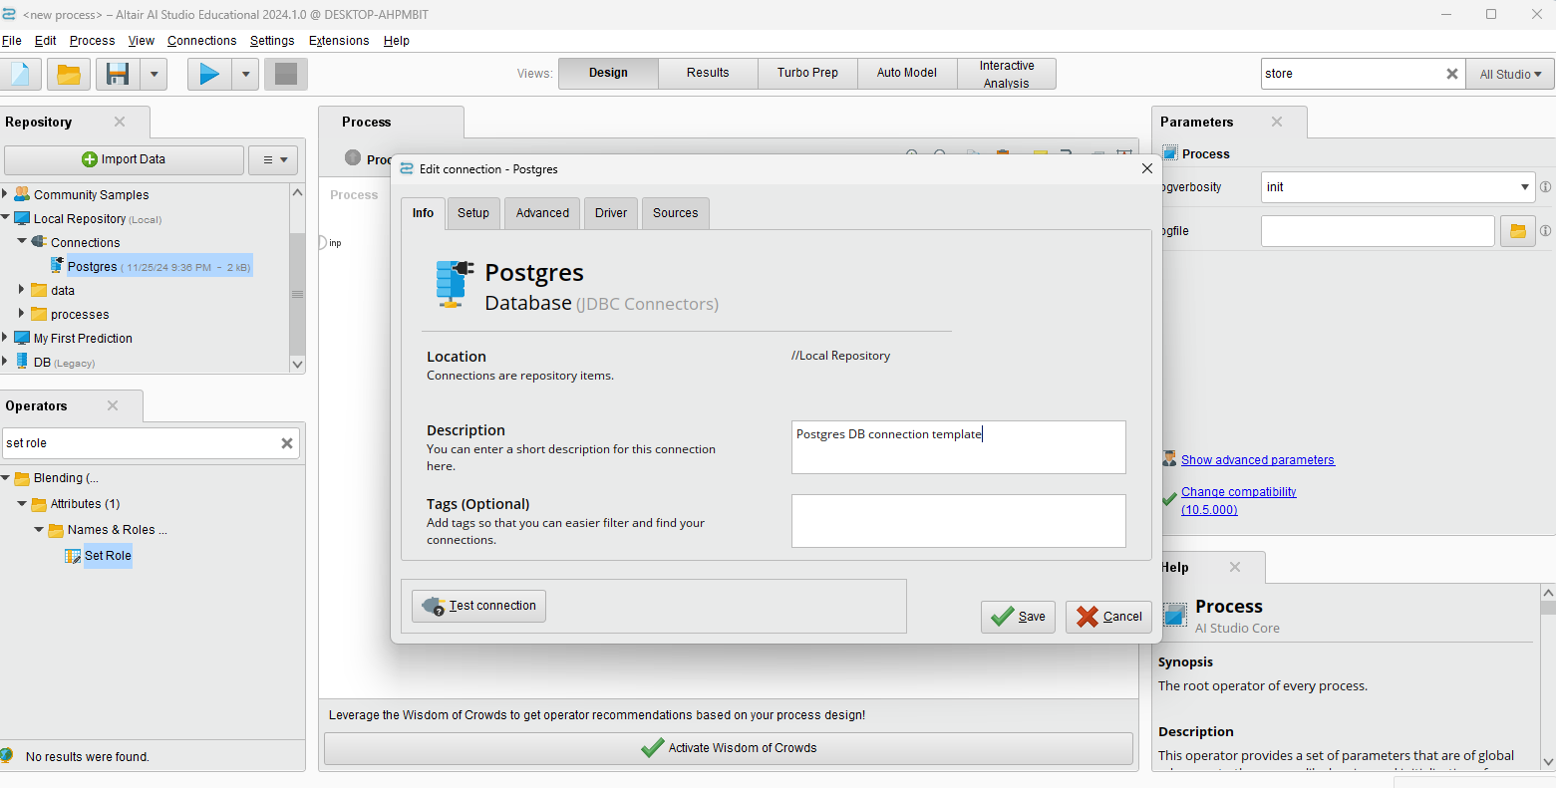

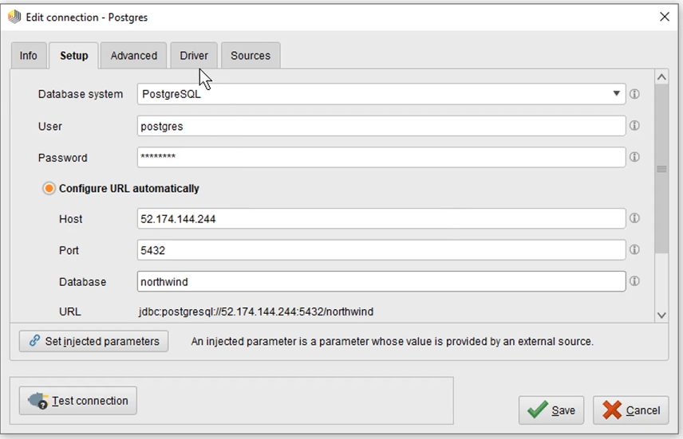

Just store it somewhere, then select it via the folder icon. The driver will be embedded into your connection.

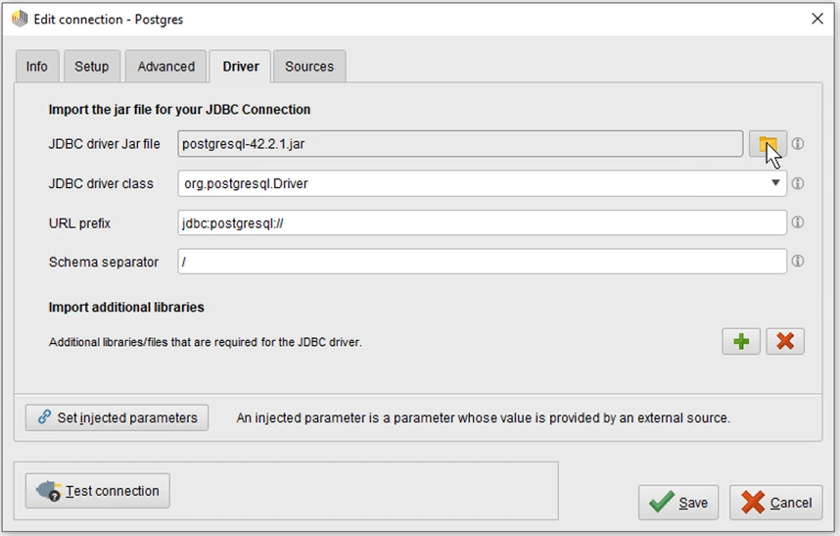

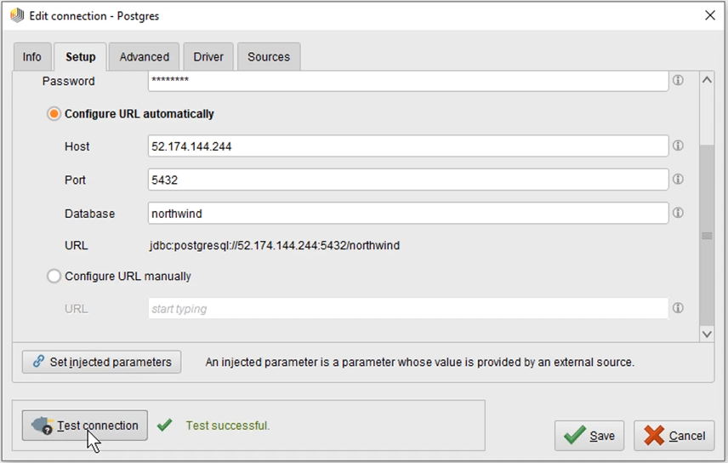

We can pull the data into the process panel. To choose what we want to extract, we will use the read database operator, which we can find in the operators panel under data access in the subfolder database. To set up the actual query, we can move to the Parameters panel. Next, we have the option to choose between retrieving the entire table by selecting the table name.

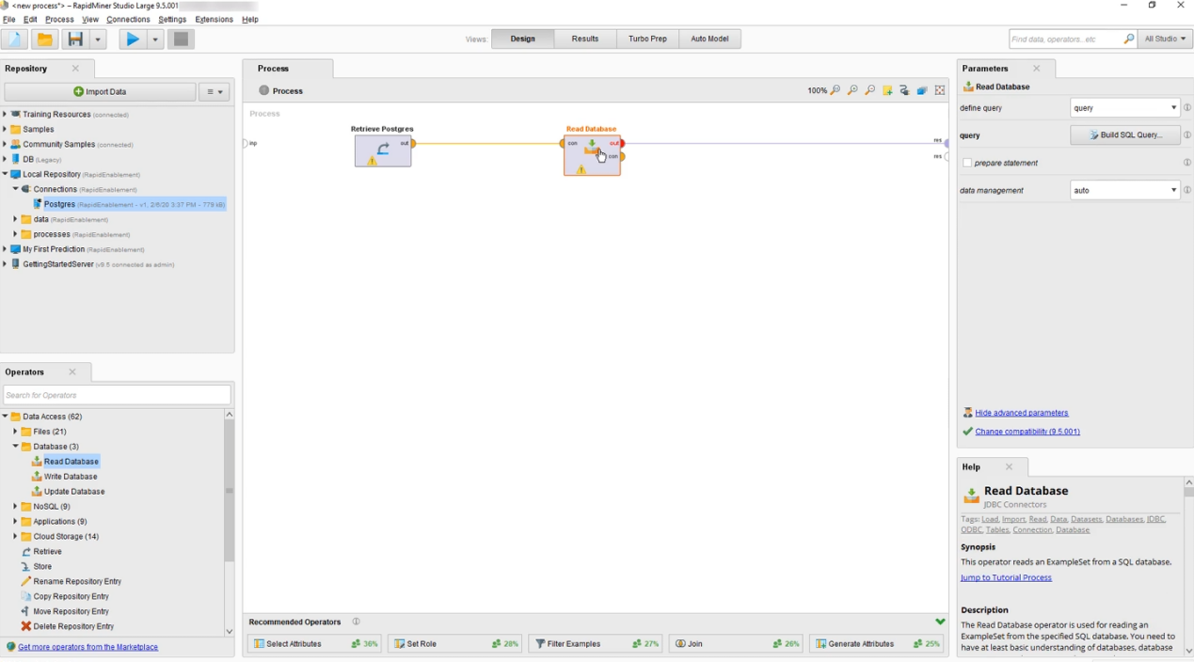

Click run button. The result:

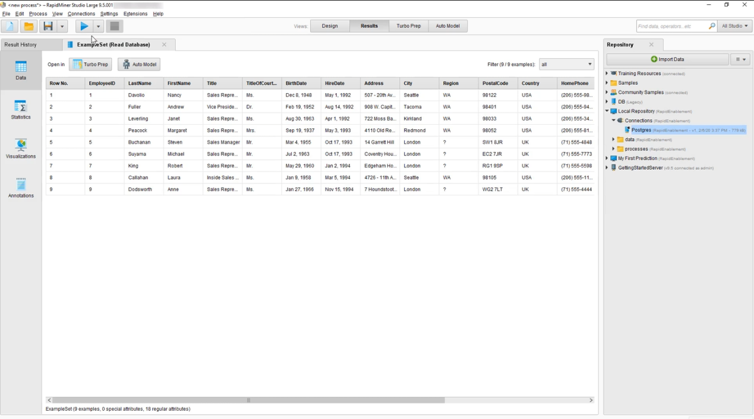

Select to edit the connection with the right mouse button. These settings like connection keep alive, timeout or the batch size can be configured here via the additional properties.

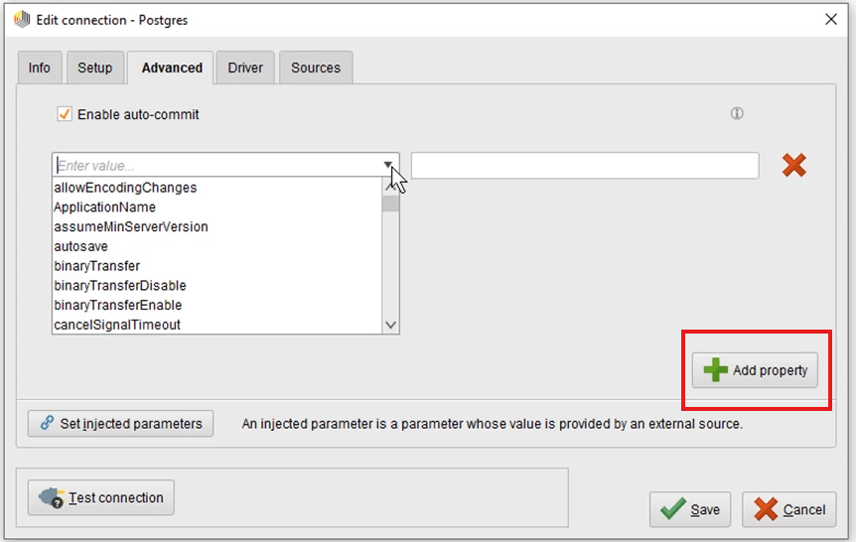

Go back to Setup type, remove the username, password and database. Then select to inject them as parameters. Take note of the macro key here which shows up as you select the ones you want to use. A macro in RapidMiner is a variable which we can set or which can be extracted during a process execution. Since macros are not protected, we may want to use a more tailored name, which we can do by adding a prefix to our macro keys.

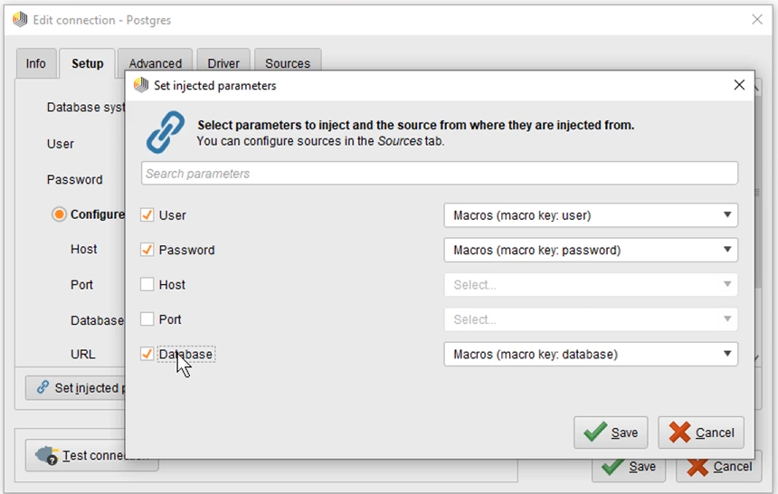

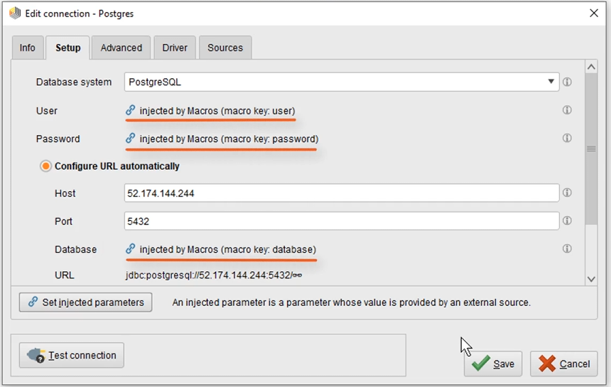

In a production process, the injection parameters could be extracted or generated on the fly and then passed in, but in our simple process, we’re going to set them manually. Make sure to get the wording right with the prefix and all.

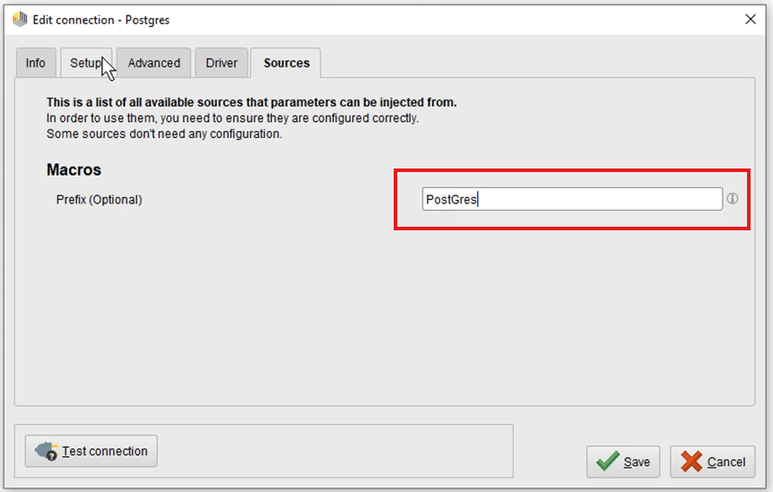

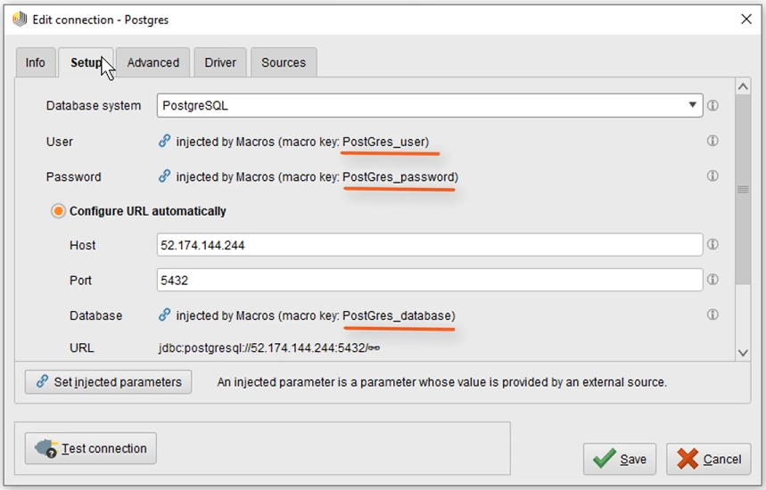

### Machine Learning

#### Creating a 'Decision Tree' Model

*Video address:* [*https://academy.rapidminer.com/learn/video/creating-a-decision-tree-model*](https://academy.rapidminer.com/learn/video/creating-a-decision-tree-model)

Building a model always works the same way in supervised learning. You will need to have data with know results flagged. 'Loyal' or 'Churn', 'true' or 'false', 'Hit' or 'miss', it doesn't really matter as long as you have flags for the model to learn from. The big advantage of a decision tree and this is also why it is so often used is that it can be presented and interpreted nicely. If you would look at the output of a Neural Network model in contrast then you could not make a lot of sense by just looking at the numbers.

Click on the data directory, highlight your customer data and drag it over. Before we actually build a model, we want to inspect our data for issues and to see if you need to do any future preparation. So click on the output port of the operator and drag a connection to the results port of the process panel to establish the connection and click the run button.

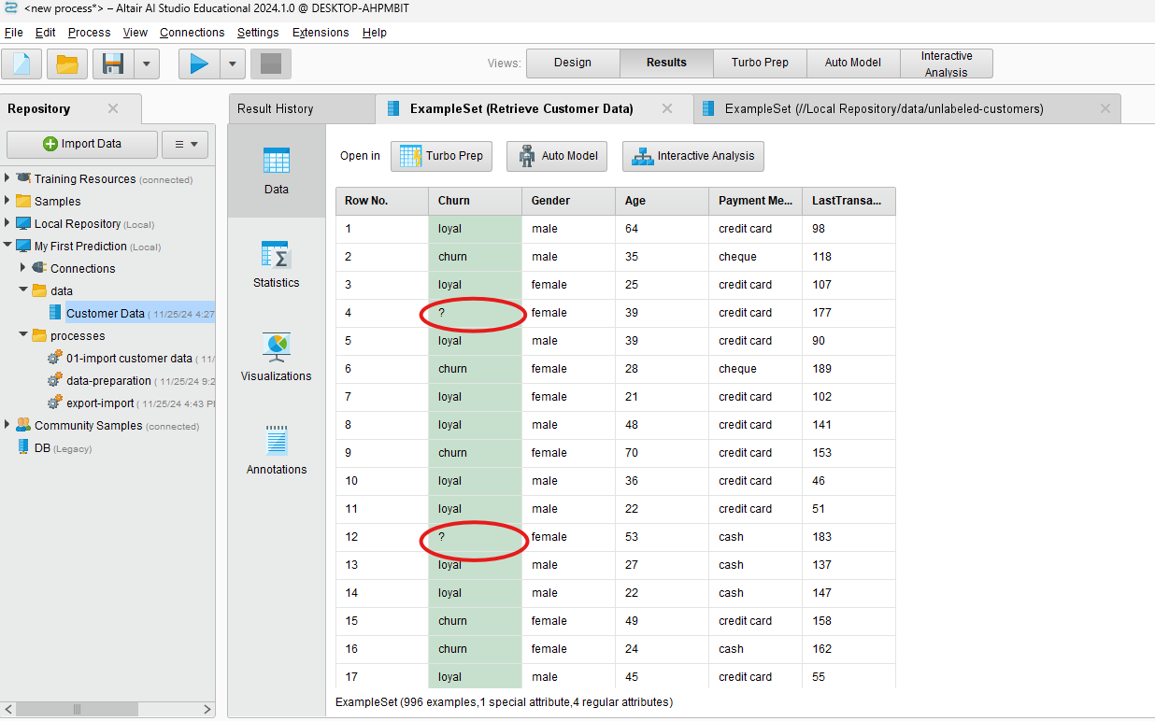

Search for an operator called filter examples. Highlight it and drag it over.

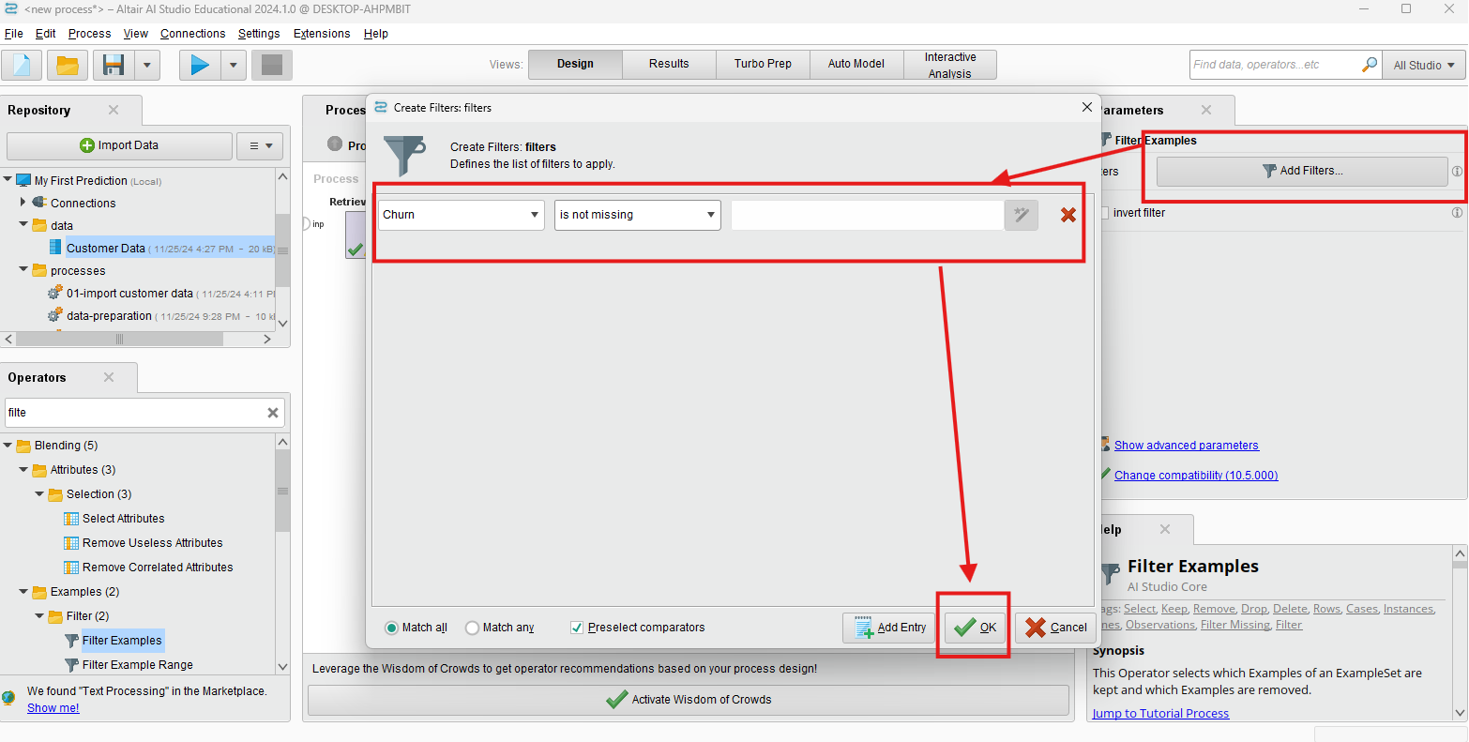

Look for a decision tree modeler. Highlight it, drag it over and drop it on the connection. And save it as 02-build decision tree. The decision tree shown as follows:

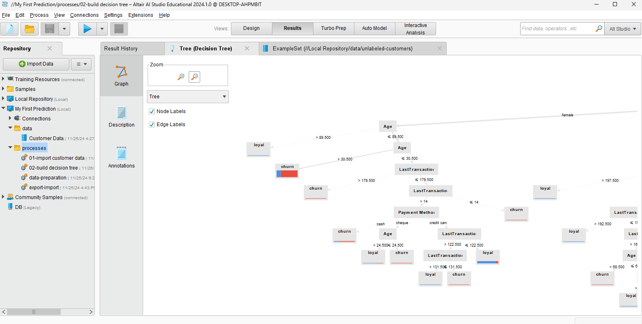

#### Applying the Model

*Video address:* [*https://academy.rapidminer.com/learn/video/applying-the-model*](https://academy.rapidminer.com/learn/video/applying-the-model)

After a model is generated it needs to be applied to some data that does not have flags or predictions associated to it yet. This process is called scoring and is a very essential step during machine learning. Often people only see the flags which associated to a certain data point but in reality most models are not actually applying a flag but the calculate a confidence for one or the other out come. So in other words the score every point which makes the terminology much more logical. In most applications the flags with the higher score is then applied to the data point.

Use 02 build decision tree model as the basis, so copy and paste it. And named 03 apply the model. Let’s go ahead and select those operators by dragging a window and just moving them a little bit down the connection. Take Filter Examples to process panel and edit it.

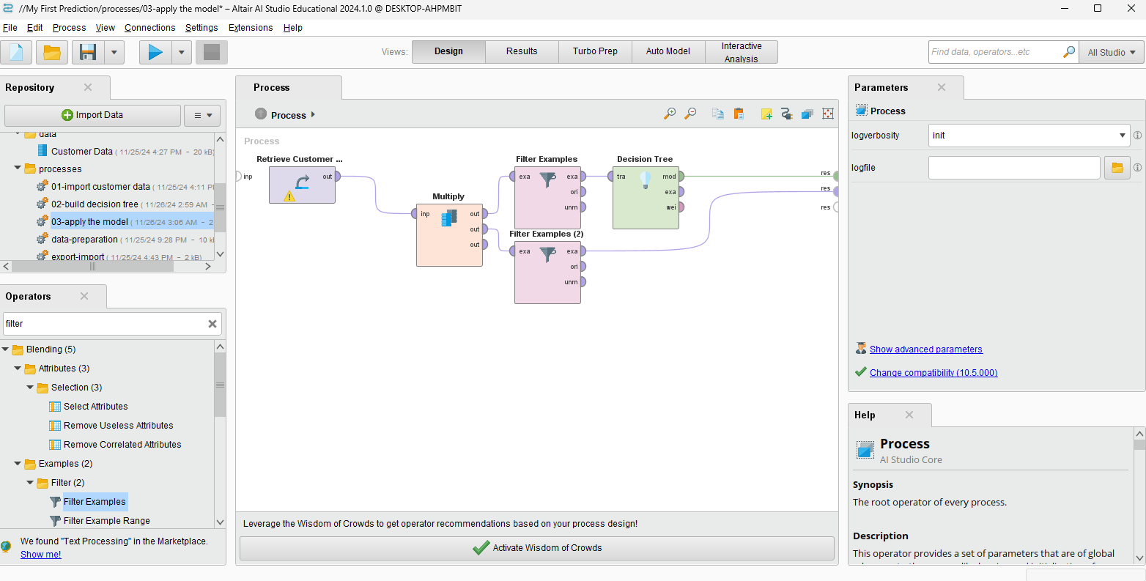

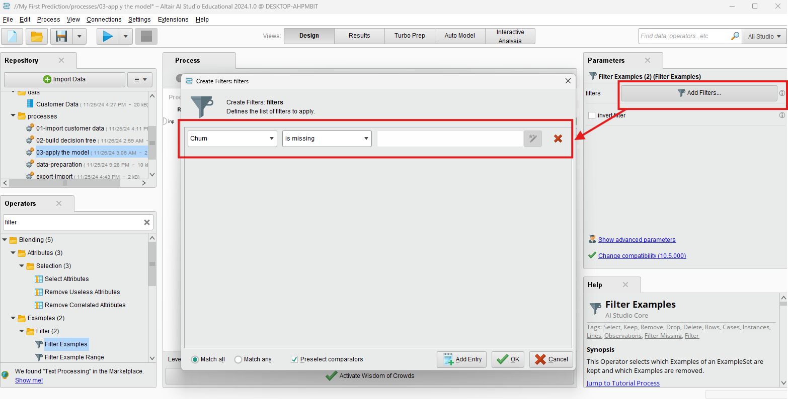

Run this process. Go back to Design. And then, search Apply Model, drop it on the upper branch. Now to combine the upper and lower branch, we can just drag the operator and drop it on the lower branch. The result shown as follows:

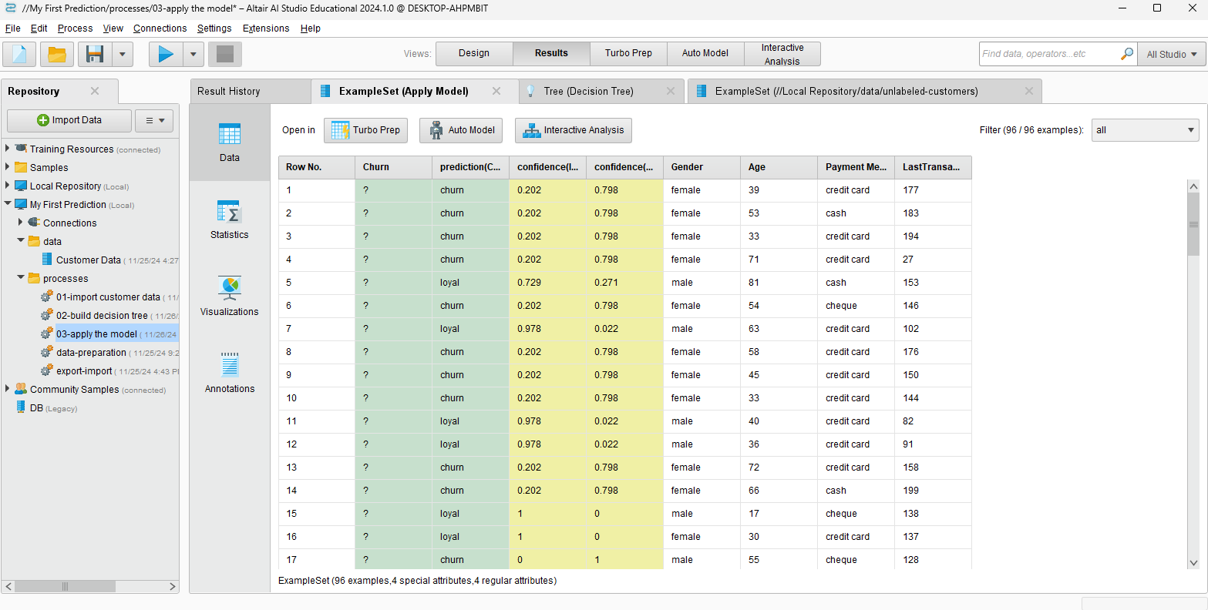

#### Testing a Model

*Video address:* [*https://academy.rapidminer.com/learn/video/testing-a-model*](https://academy.rapidminer.com/learn/video/testing-a-model)

It is very tempting to train a model on a data-set and then see how it would do predicting the labels it just learned from. With the performance operator you basically do the comparison of right and wrong predictions and sum them up. However it is an often made mistake to measure the performance of a model on one and them same data set. Doing that does not help at all with assessing how the model would perform on unseen data or in other words how it generalizes.

Get an operator called Apply Model. We need to connect the decision tree MOD port that stands for model to the Apply Model operator’s input MOD port. The second input port is UNL, which stands for unlabeled data. So it is requesting the data on which we want to apply our prediction.

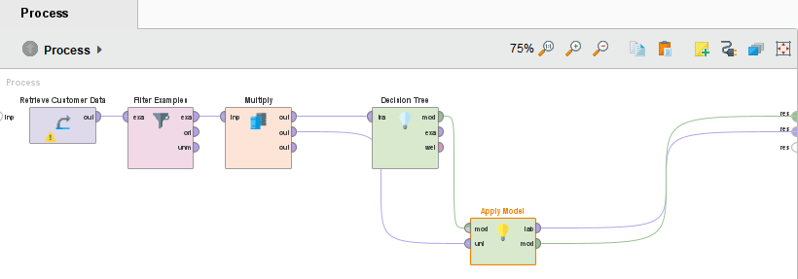

Use a performance operator and drag it. And save it named 04 testing the model. And then run process.

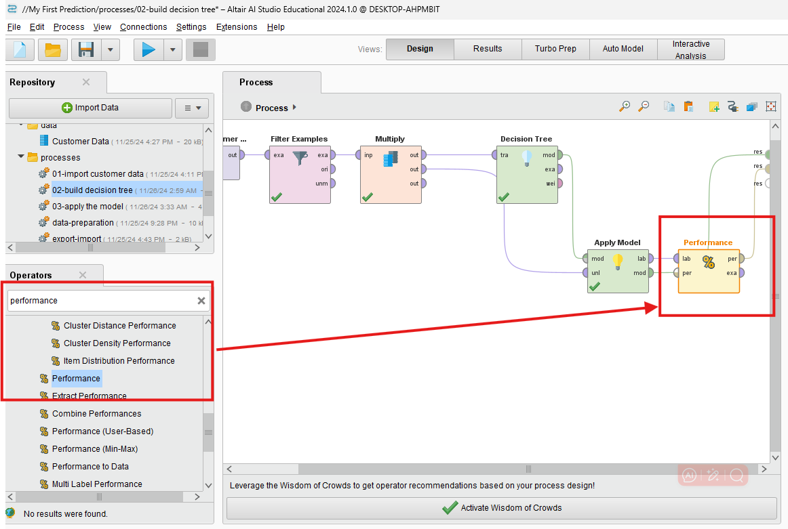

Result:

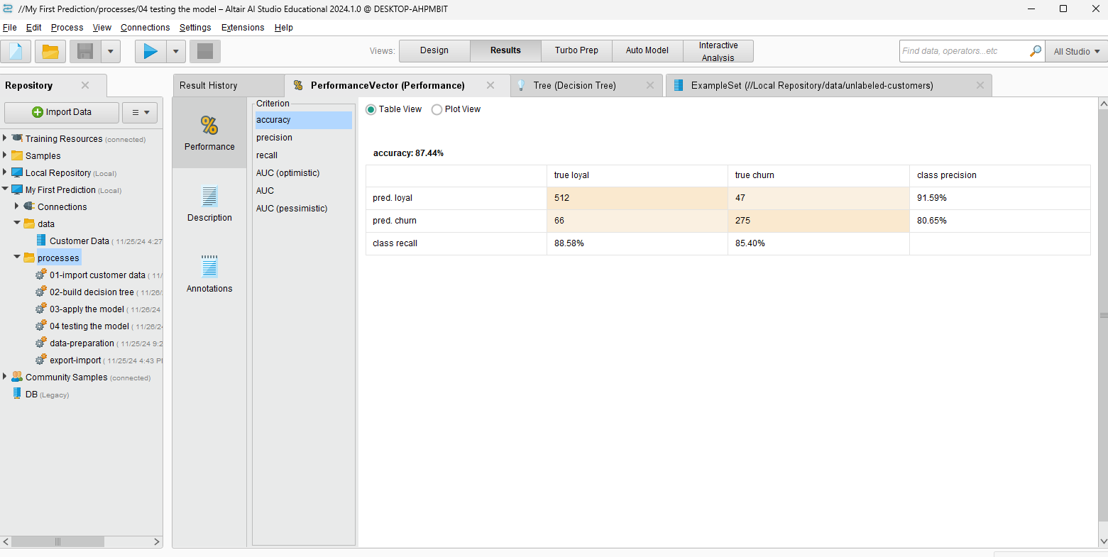

#### Validating a Model

*Video address:*[*https://academy.rapidminer.com/learn/video/validating-a-model*](https://academy.rapidminer.com/learn/video/validating-a-model)

The cross validation allows you to check your models performance on one dataset which you use for training and testing. If you use a cross validation then you are in fact identifying the 'prediction error' and not the 'training error' and here is why. The cross validation splits your data into pieces. Similar to a split validation it trains on one part and then tests on the other. In contrast to Split validation this is then not done only once but in an iterative approach to makes sure all the data can be used for testing.

So now you get a proper performance estimate of your model. Understanding that output is another thing. It is usually displayed in a confusion matrix and there are many ways to interpret it.

Come over to our operator panel and search for cross validation. Drag that over the panel and connect the port. The cross-validation operator you can see two operator boxes stacked on top of each other. Double click it. Now we actually have two new windows.

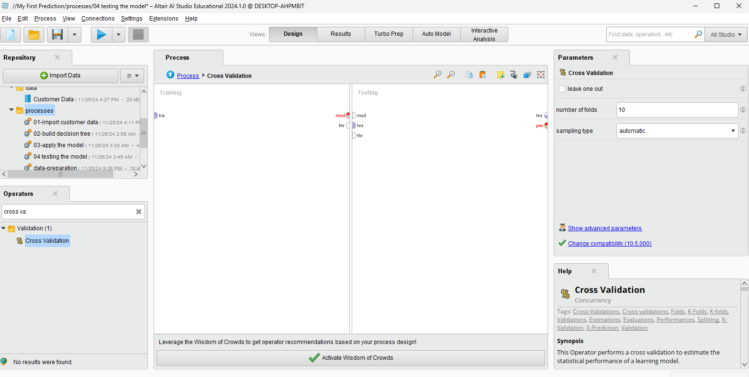

Arrange the operators like the figure as follows:

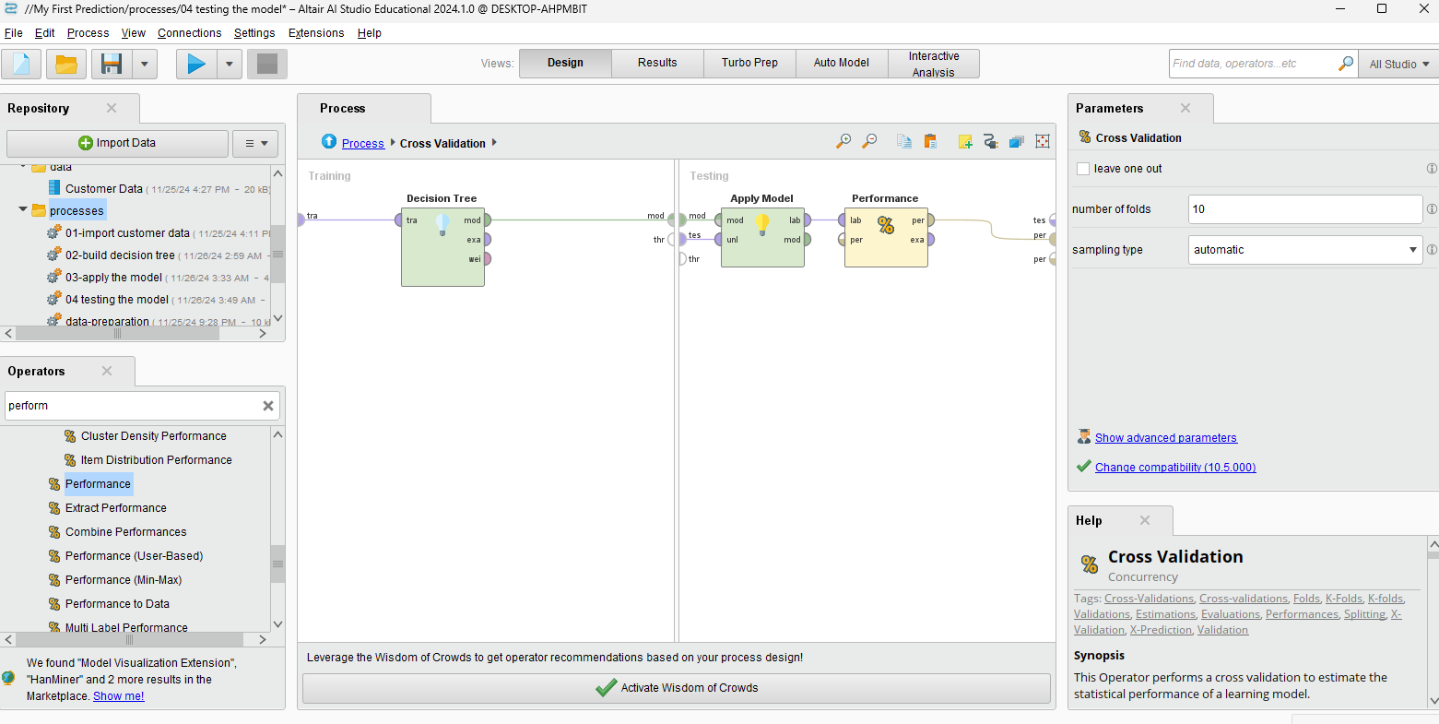

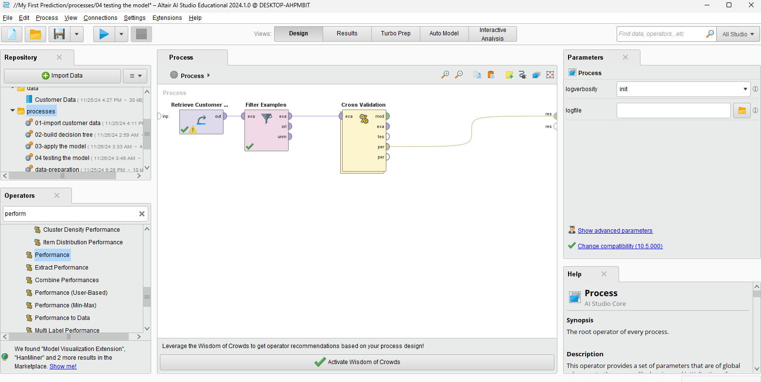

Result:

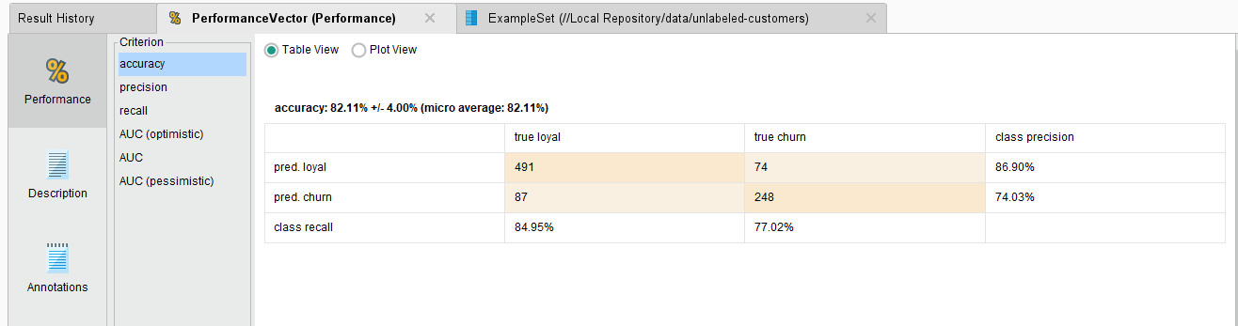

The overall accuracy of all predictions achieved by the 10 models, each of which made a prediction of 90 examples, after being trained on the other roughly 800, is nearly 82%. The plus minus is one standard deviation, which is calculated from our 10 individual model accuracies.